SPECIAL PROJECTS
Open Store Visit from the main page.
Windows | Windows Phone
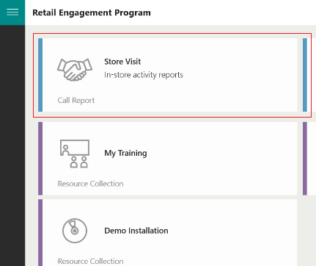 | 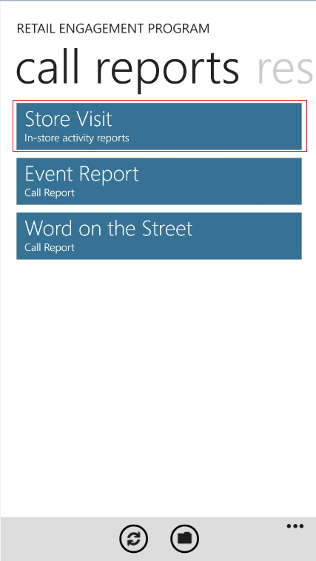

Stores in which have active Special Projects will now display in red:

Windows | Windows Phone
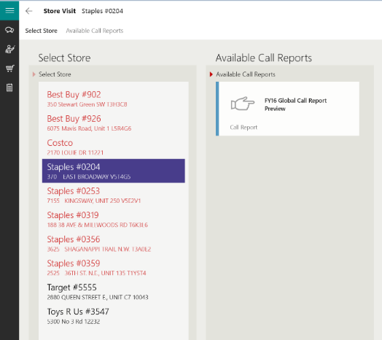 | 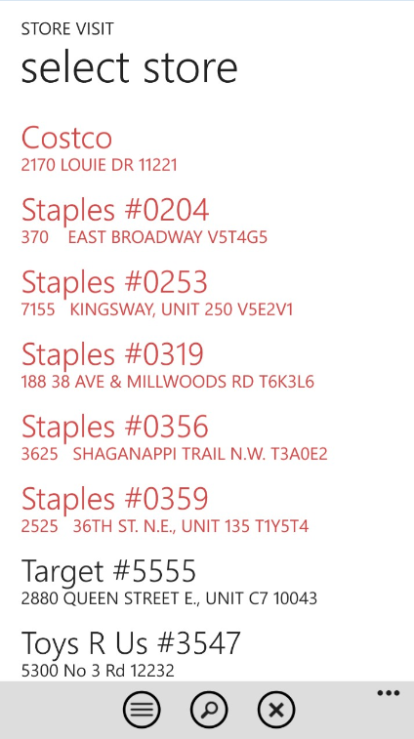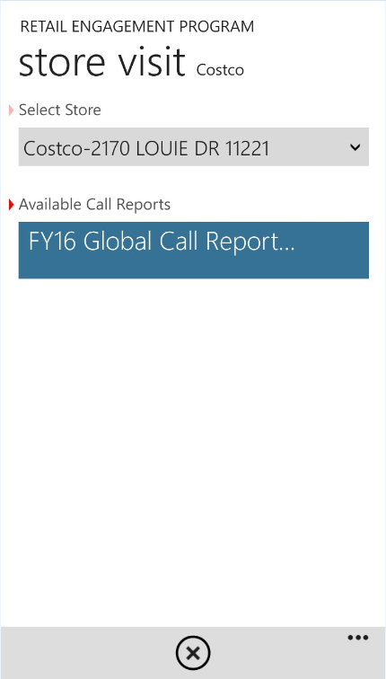

Special Projects behave similar to Word on the Street, RP Training, etc. They are technically forms within forms. Special Projects are all placed in a new section right within the Store Visit Call Reports. When present, they will always be the second section after Visit Details as shown here:
Windows | Windows Phone
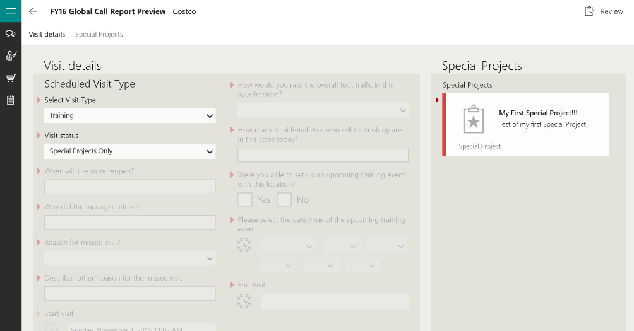 | 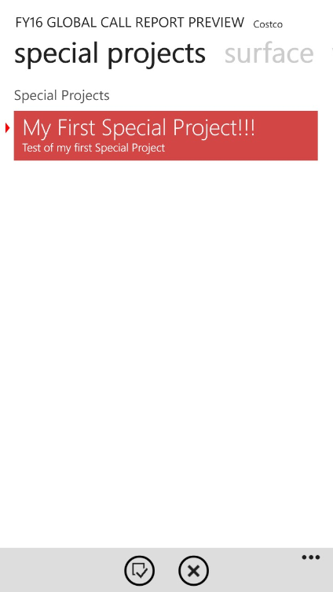

Clicking on a Special Project now acts similar to all other reports: complete the times and submit.
Important Notes:
- If you are at that store to conduct only a Special Project(s), select Special Projects Only from visit status as shown here. This will de-activate all other required and non-required questions:
Windows | Windows Phone
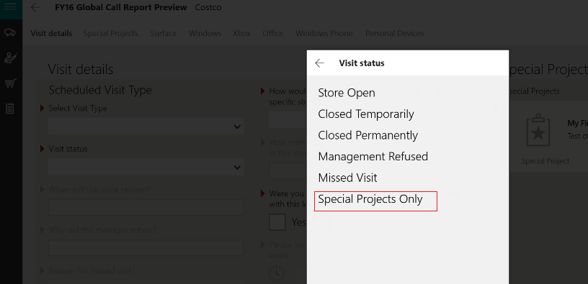 | 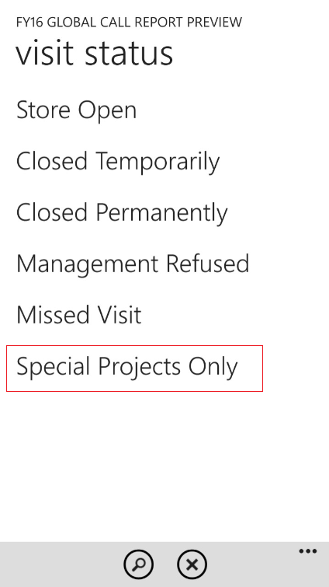

- There is no way to save a half of a Special Project. When conducting a Special Project, you can either submit it or cancel it all together.
- Special Projects can be mandatory. Mandatory Special Projects will have the red carrot/triangle next to them. If you attempt to submit a store visit without completing a mandatory Special Project, you will get a warning pop-up message to complete.

