

Special Projects - Trial Guide
Version 110315

November 3rd, 2105

SPECIAL PROJECTS TRIAL GUIDE


After reading this document, you should be able to:
Create a special project (SP) and distribute that project to your field labor teams.
Show and demonstrate to your field labor teams how and when to conduct a SP on Windows and Windows Phone.
Collect SP Project data; report and export as needed; dashboard as desired.

Table of Contents
Overview 4
Creating a Special Project 5
Using Special Projects in the Field 9
Special Project Rules and Behavior 12
Special Project Visit Only 12
Reporting and Dashboards 13
Time Management Report 14
Troubleshooting 15
Support 16

Overview
This document is a pre-global release document. If you have received this, you have been selected to help conduct a short field trial using Special Projects. You have been asked to create Special Projects, deploy them to your field reps and provide feedback.
Today, all Admins in each country are forced to place additional questions for your field labor teams as additional questions within the regular store visit call report.
Special Projects (SP) now enables you to move your questions out of this larger call report and manage your own questions/forms separately. These questions are not tracked globally and will not support any global KPIs.
So, what does this do for you overall?
- The larger call report used today will get much smaller; forms will load faster.
- You will now have much more organized control over your own questions and content to manage your way.
Feedback:
If you have any issues or concerns with this document or with the usage of Special Projects, please send email to:
- Email: msftreps@westlakesoftware.com
- Subject Line: Special Project Feedback
- Body: Provide enough detail as possible to allow us to replicate the problem you discovered.
- Suggestions are welcome.
Thank you for your assistance. We hope to launch this new feature to all countries soon after this short trial period.
Westlake Management Team

Creating a Special Project
Creating a Special Project (SP) has been set up to be similar as to how you create a new call report today.
- Login to MSFTREPS.com
- Select Create from the Call Report Menu
- On the left, select the new: Corporate: Special Projects Template
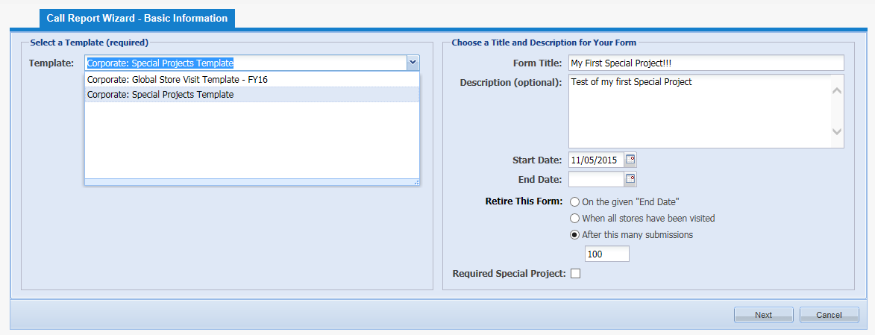
Once you have selected the Special Projects Template on the left, on the right:
- Create a form title
- Description if desired (optional)
- Set Start Date in which the SP is to go live.
- Set an End Date in which the SP becomes in-active
- Set details on the End Date. Supported today are:
  - On the Given End Date
  - When each unique store has been visited once
  - After a certain number of stores have been visited
- Denote if you want this Special Project to be required at that Store Visit or Not.
- Select the Next button.
NOTE: If you want to test a SP on your device, set the start date to today or earlier. If you set the date in the future, the SP will not show up on your device until that day.

- Select the titles of the Reps in which you want to assign Special Projects to by checking next to each title to assign.
- Select the Next button.
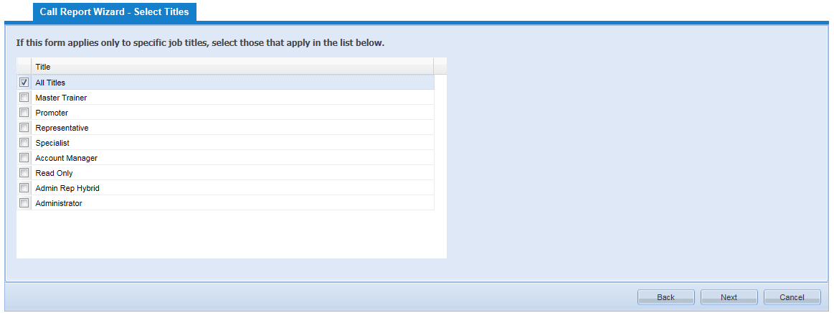

- Select the Chains/Classifications in which you want to assign the SP.
- Select the Next Button
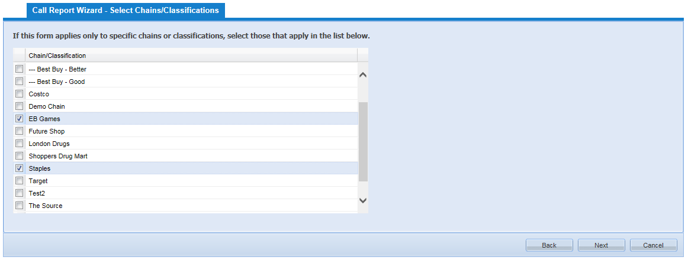

Similar to the Store Visit Call Report, there is a short template that is required when using Special Projects. Mandatory items are:
- Start time (start timer)
- End time (end timer).
- Project Status (completed or incomplete).
- Reason for incomplete.
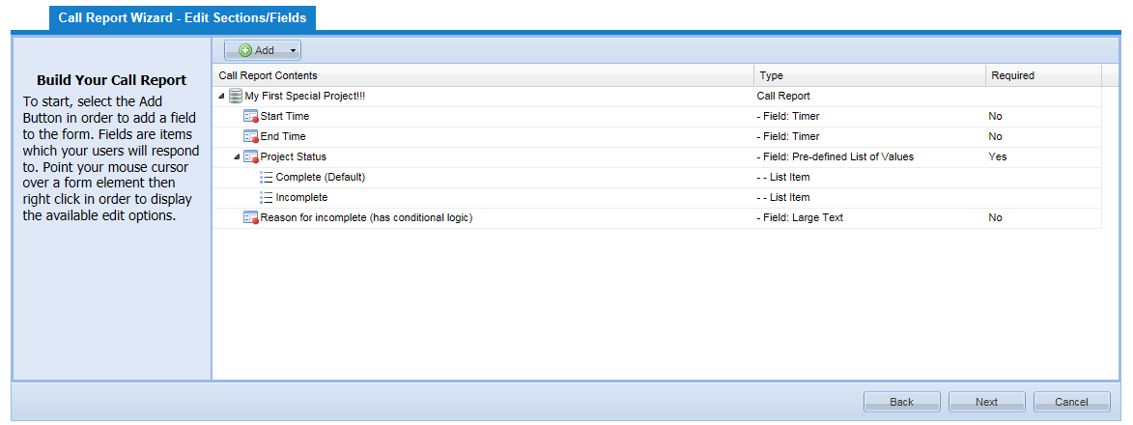
Note: SPs are designed specifically to have a Rep open the form, complete the SP, submit it and move back to other work when applicable. Per design, there is NO OPTION to partially save a SP.
The SP form is now ready for you to create.
What can a Special Project be? Virtually anything you want. This is an open template style form in which you can place all of your miscellaneous questions into or organize groups of questions into their own Special Project call report.
Forms are built out EXACTLY the way in which you manage Store Visit forms today.
Select the Add Button:
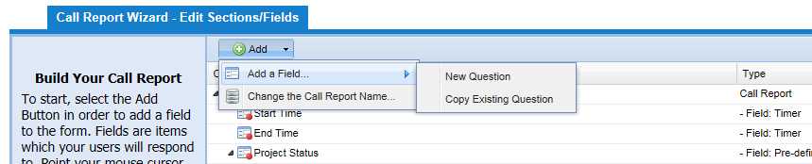
Note: See documentation/reference materials on how to build out call reports for steps to build out a SP report.
Note: We have made questions you created locally in the global call reports available in the Special Projects database to allow you to more easily port over your questions to this new format.
The example below shows three new items that have been added to the SP form:
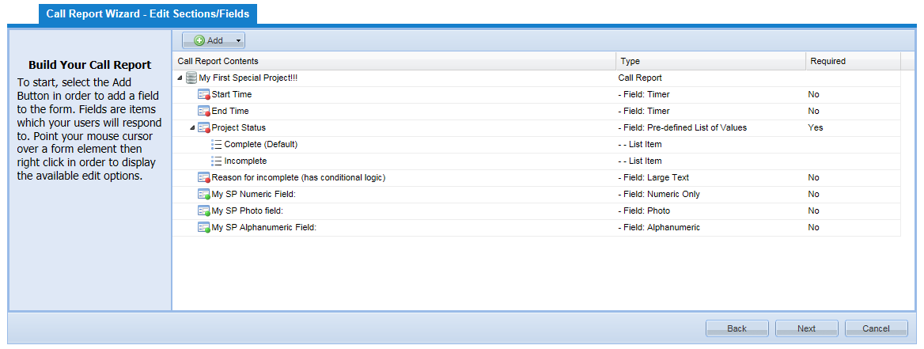
They are titled:
- My SP Numeric Field:
- My SP Photo Field:
- My SP Alphanumeric Field:

- Select Next Button
- Select Finish Button
This takes you back to the Call Report Management Page. Your SP should now be listed. The example here is titled: My First Special Project!!!
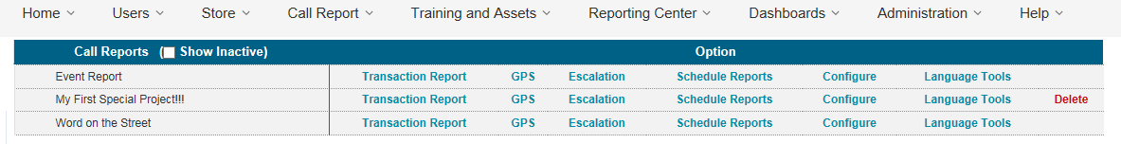
Controls for SPs are the same as a call report in the Call Report Management Window. Open transaction reports to view collected data, set escalations and scheduled reports, configuration options and language tools, etc.
The set-up of a Special Project is now complete.

Using Special Projects in the Field
Both the Windows version and the Phone version support Special Projects. Make sure your devices are using these versions or higher to make this work. These new versions were placed into the store for acceptance on November 3rd, 2015:
- Windows: 2.1.0.20 or greater
- Windows Phone: 2.8.0.1 or greater
Special Projects will NOT function properly without these versions or higher. You can check the version on your device from the Settings and About page for reference.
From the main landing page, select Store Visit:
Windows | Windows Phone
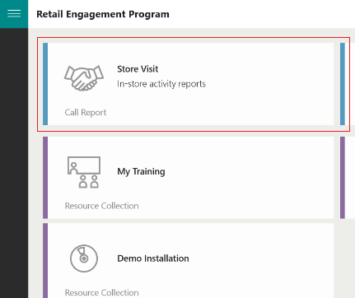 | 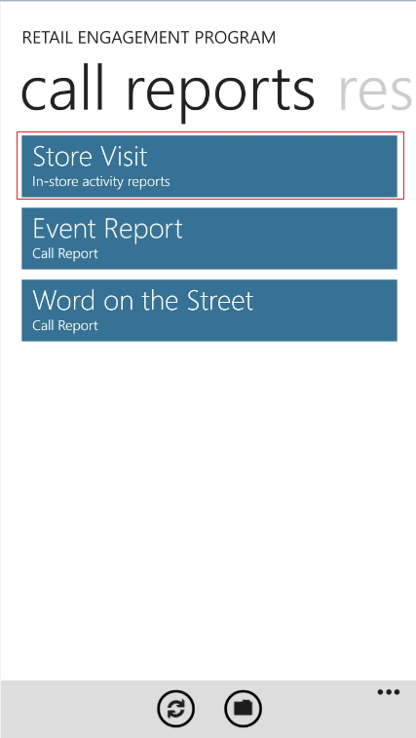

The store list has now changed. If a Special Project is assigned to that store, the store name will now appear in Red as shown. Select your store and call report just as you normally do today.
Windows | Windows Phone
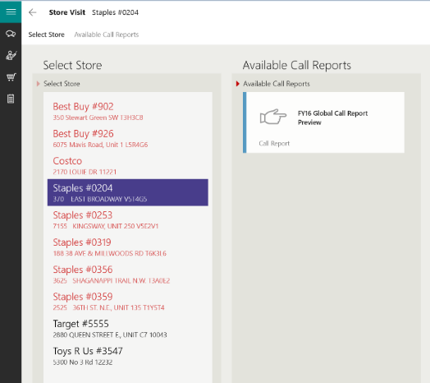 | 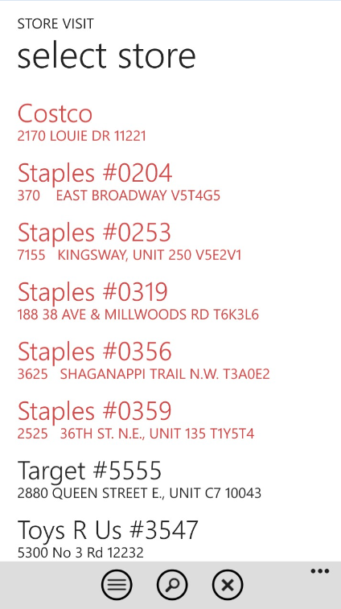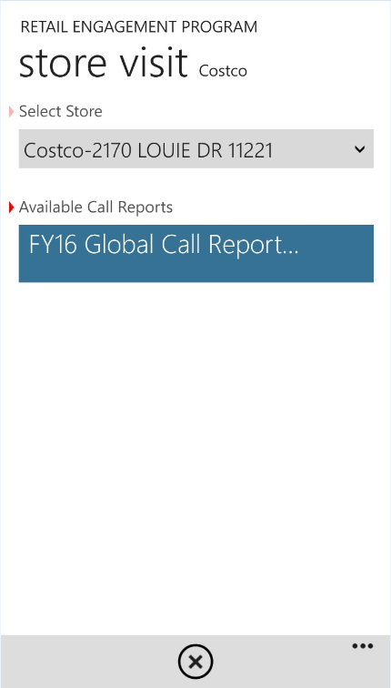

Special Projects now behaves similar to Word on the Street, RP Training, etc. They are technically forms within forms.
However, these are not placed into the tool or menu bar. Special Projects are placed in a new section right within the Store Visit Call Reports. When present, they will always be the second section after Visit Details as shown here:
Windows | Windows Phone
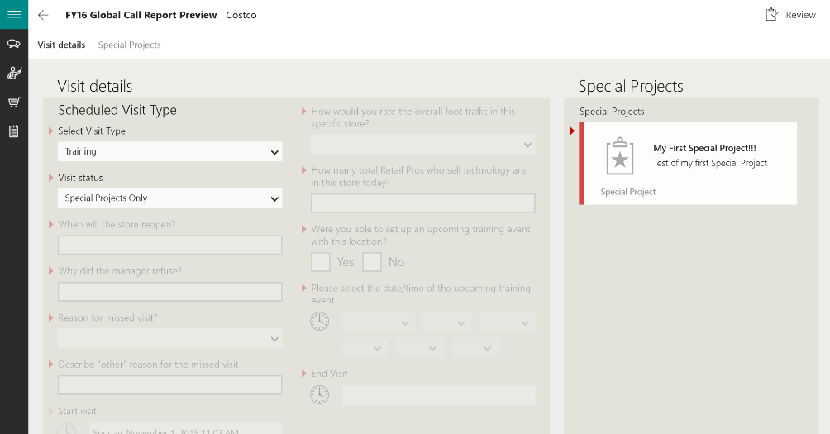 | 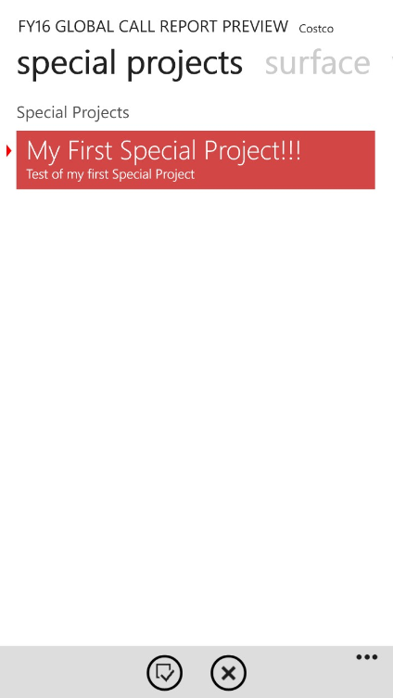

Opening our example Special Project, the template fields and the three fields we added are now shown. Complete these forms like you would any other form:
Windows | Windows Phone
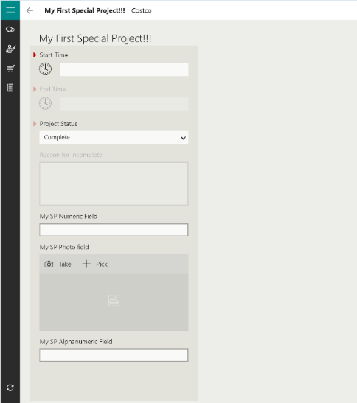 | 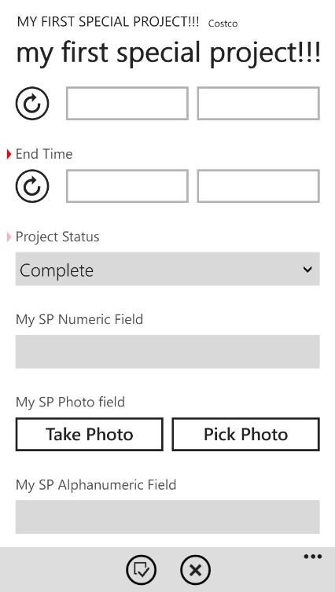

Special Project Rules and Behavior
Similar to call report questions, if you see the red carrot next to a Special Project, that SP is required during a store visit. Reps will be unable to submit a call report without having completed the Special Project. Note, within the Special Project, the required template does support an option to show Incomplete and reason(s) why. If you attempt to submit a call report when a SP is required, you will get a nag/reminder screen that the SP needs to be completed:
Windows | Windows Phone
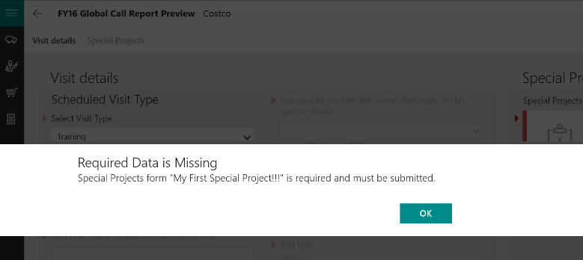 | 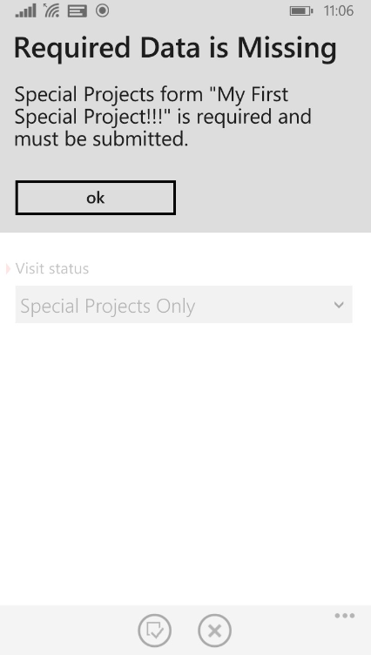

Special Project Visit Only
This can be done by selecting Special Projects Only from the Visit Status selection option in the Store Visit Call Report shown below. This will turn off all other questions in the call report and allow the Rep to just conduct Special Project visits.
Note: when you select Special Projects Only, the visit does not count towards compliance and is not included in the store visit KPIs.
Windows | Windows Phone
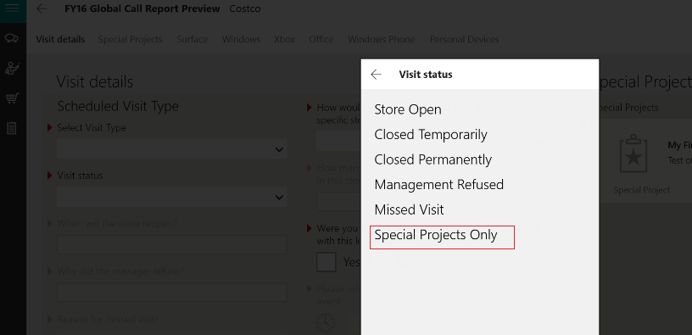 | 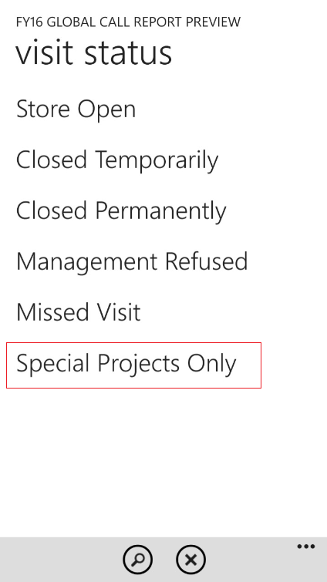

Reporting and Dashboards
Similar to how the store visit call reports function, Special Projects support the same reporting and dashboard functions.
- Manage Call Reports
  - Transaction Reporting and Exporting
  - Escalations
  - Scheduled Reports
  - Configuration Options
  - Language Tools
- Custom Reporting Center
  - All available configuration and extraction features
- Dashboards
  - Extract and display My Saved Items on any My Dashboard
  - New General Common Charts and Graphs option for tracking Special Projects.
    - New Items looks like this:
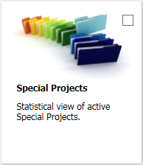

    - Displays in My Dashboard with a simple count of total submissions for the filter ranges.
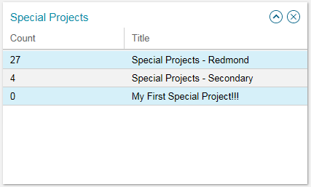

Time Management Report
There is a new report found under the Sub-Dashboard: Compliance. When both a Store Visit form is completed with a Special Project, time is tracked using these items/metrics:
- Country
- # of Special Projects
- # of Special Projects Submissions
- Time in Store
- Call Report Time in Store
- Special Projects Time in Store
- % of Time Spent on Special Projects

Troubleshooting
My Special Projects are not showing up on the field Rep tool.
- Is your Special Project Start Date tomorrow or later? If you have this set for the future, the program is operating as designed. For testing, go back to Manage Call Reports, Select Config next to your SP:
Set your Start Date to today or earlier.
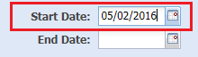
- Did you assign the SP to that retailer? Enter settings to check.
- Did you assign the SP to that title? Enter settings to check.

Support
There are two ways to contact us for help and support:
Website: https://www.msftreps.com and then use the Help menu to open a support ticket.
Email: msftreps@westlakesoftware.com
Make sure if you include all necessary details to describe the issue. Details include:
- Screenshots ( if applicable)
- Contact information
- Device model / type
- Every step taken that caused the problem (filter settings, what you clicked on and in what order, can you repeat the process, etc.).
- Expected behavior and behavior you experienced
Thank you
Westlake Support Team

