

Store Selection User Guide
Administrator Version

September 9th, 2016

Store Selection Administrator Guide


After reading this document, you should be able to:
Understand how to train your reps to schedule a new store with the Windows or Windows Phone app using the new Add Stores button.

Overview
The store selection feature in the REP tool has been updated with a more efficient server - app download, or smart data management. Now, data for only the stores needed that day will be requested from the server. This will improve performance of the app, especially with “value tier” device models. The size of the data transfer between server and REP tool in both Windows and Windows Phone will be considerably reduced.
Important items to know before you start:
- There is a new button named ‘Add Stores’ added to the Select Store page of inside of Store Visit.
- Ad hoc visits done by the Rep will be displayed on the calendar page of msftreps.com with status as ‘Unscheduled’.
- Windows app versions 3.0.9.0 and Windows Phone app 3.0.9.0 (or higher) support this new capability.
- An Internet connection is required to revise the store selection list.

Add Stores Button 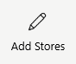
The Add Stores button is introduced in the Select Store page for updating the store list with unscheduled stores. The added store remains in the list for 24 hours and will be automatically removed after that.
The changes in the calendar and REP app related to the Add Stores button are:
- There are no more ‘Today’s Stores’ or ‘All Assigned Stores’ lists in the app’s store selection page of Store Visit.
- All the stores which are scheduled through the Calendar web application will be displayed in the main Store list. If none are scheduled, then the first store list will appear blank.
- All stores assigned to the Rep will be displayed in Select Stores for Today list.
Steps for adding unscheduled stores to the stores list:
- From the home screen of REP Tool, click on the Store Visit tile.
- The Select Store page contains a list of stores which are scheduled through calendar page in the web application.
- For adding stores which are not in the list, click the Add Stores button.
- A pop-up will be displayed with the list of all assigned stores.
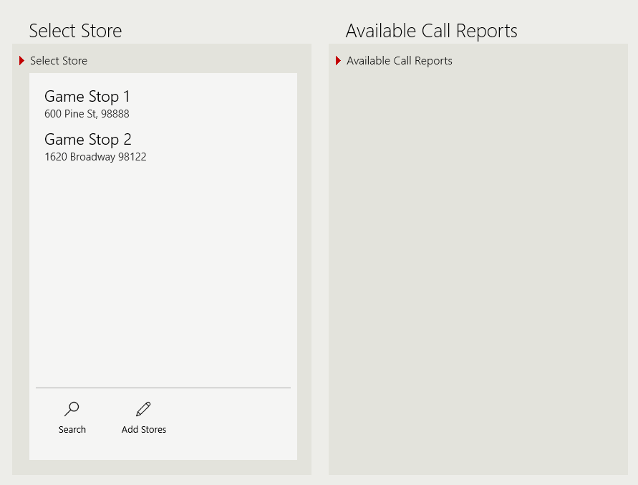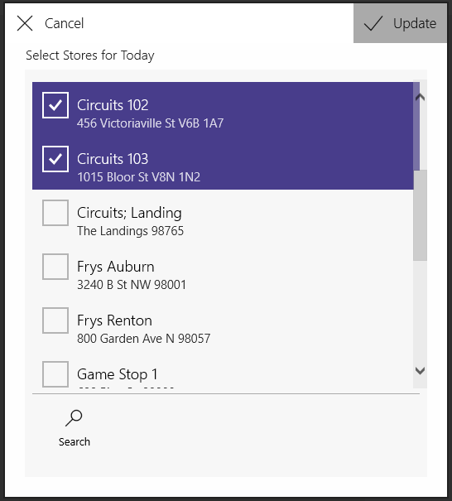
- Checkmark the stores that are to be added to the Select Store list
- Click the Update (or Done on phone) button to add the selected stores to the list. The app will now contact the REP server to download the stores. Click the Cancel button to clear the selections if needed.
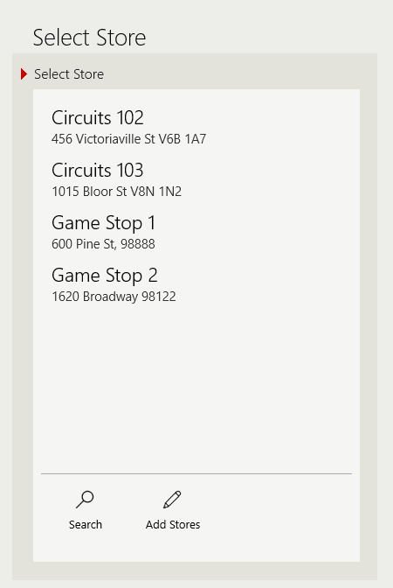
Updated StoreList
- Next, the Select Store list will be updated with the selected stores, provided there is an Internet connection available.
Tip: When adding stores to the Select Store list, each change made to the list with the Add Stores button will overwrite the previous selection.
Reps can now select available call reports for these stores and proceed as usual. The submissions of the newly added stores will be displayed as ‘Unscheduled’ in the calendar page of web application.

Windows Phone
Same steps as Windows above, but in a more compact format.
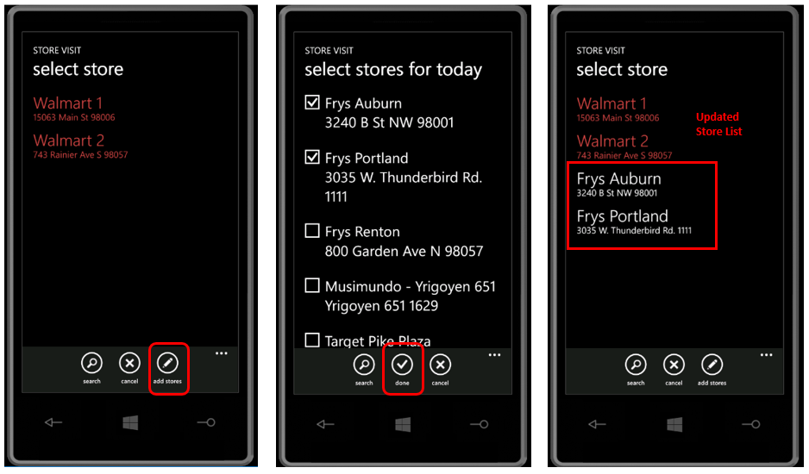

Support
There are two ways to contact us for help and support:
Website: Use the Help menu to open a support ticket.
Email: msftreps@westlakesoftware.com
Make sure if you include all necessary details to describe the issue. Details include:
- Screenshots (if applicable)
- Contact information with 10 digit REP ID and country
- Device model / type
- Steps taken that lead to the problem
- Expected behavior and behavior you experienced

