Smart Data Management - Overview
The store selection feature in the REP tool has been updated with a more efficient server - app download, or smart data management. With this change, data for only the stores needed that day will be requested from the server. Additional stores can be selected and downloaded for unscheduled visits, with Internet connection.
Windows App
The Add Stores button has replaced All Assigned Stores and Today’s Stores in the Select Store page for updating the store list with unscheduled stores. Added stores remain in the list for 24 hours and will be automatically removed after that. All the stores which are scheduled through the Calendar web application will be displayed in the main Store list. If none are scheduled, then the first store list will appear blank.
Steps for adding unscheduled stores to the stores list:
- Click on the Store Visit tile to view the Select Store page. A list of stores which are scheduled through the Calendar page in the web application is displayed.
- For adding stores which are not in the list, click the Add Stores button.
- A pop-up will be displayed with the list of all assigned stores.

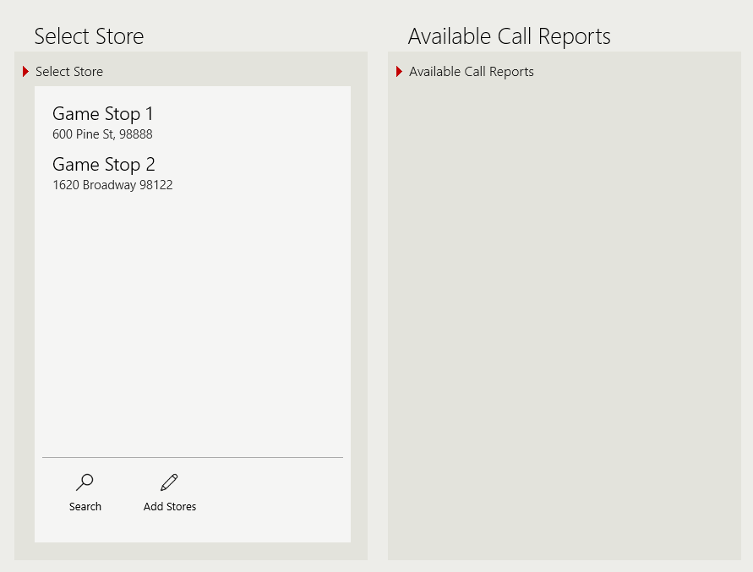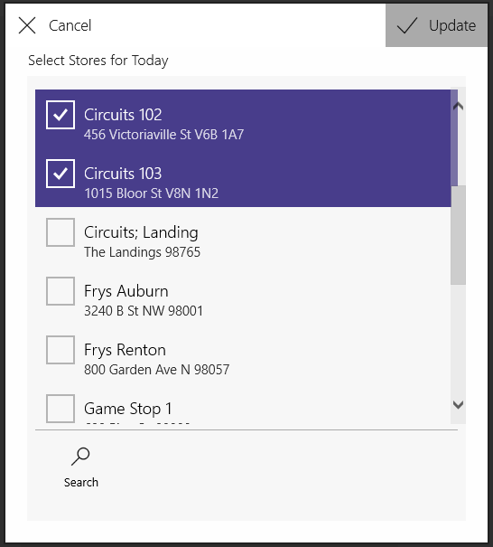

- Checkmark the stores that are to be added to the Select Store list.
- Click the Update (or Done on phone) button to add the selected stores to the list. The app will now contact the REP server to download the stores.
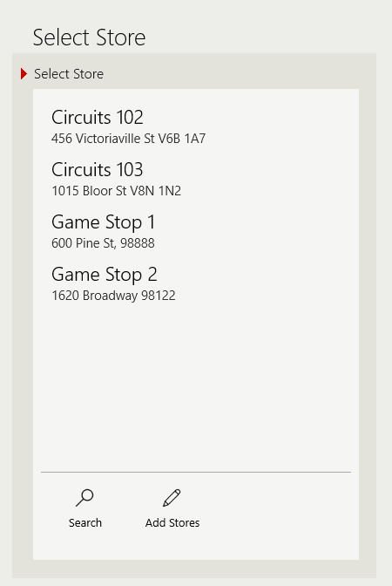
Updated Store List after download.
- Next, the Select Store list will be updated with the selected stores, provided there is an Internet connection available.
- Tip: When adding stores to the Select Store list, each change made to the list with the Add Stores button will overwrite the previous selection.
Windows Phone
Same steps as Windows above, but in a more compact format.
