Overview
A new mobile-enabled tool has been added to REP 4.0 apps to allow easy access for Reps to view trends of historical question data from previous location visits. (Internet connection is required.) The new Trend Report can also be accessed online by Admins.
Trend Report
Linked to Store Visit Report data, the Trend Report will provide a simple and easy to read graphical display of the last 5 responses, shown individually for each question over the previous 150 days.
Reporting page included details:
- Yes or No Questions
- Single Select Questions
- Multiple Select Questions
- Organized by Product
- Organized by Global, Regional and Local Questions
- On the app: a button (or link on iOS) added to Visit Details in the Store Visit Report
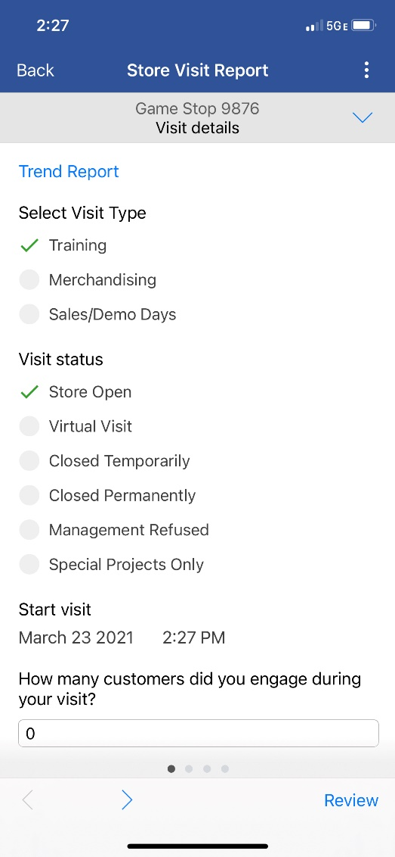
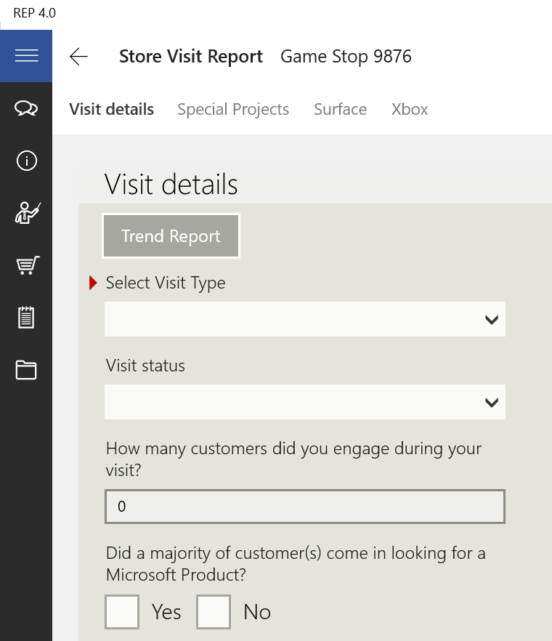
Windows and iOS view
What Value Does It Bring?
As you can see from the graphic below, the Xbox section trends reveal areas of improvement, some of decline, and areas of consistency over the course of previous visits. By seeing the last 5 times how a question was answered, you can see trends upwards, trends downwards to trends staying consistent. This can provide easy to view and understand patterns in a particular location otherwise harder to detect; especially with different Reps visiting the same store over time.
What is being reported?
Each question is individualized for up to 5 previous responses. However, it is possible that in the entirety of the report page, more than 5 visit submissions provided the included data. That will often be the case. Also, some questions may not have 5 responses within 150 days and the chart may have “blanks” in response columns. Read more below about how response columns are identified with hover tips.
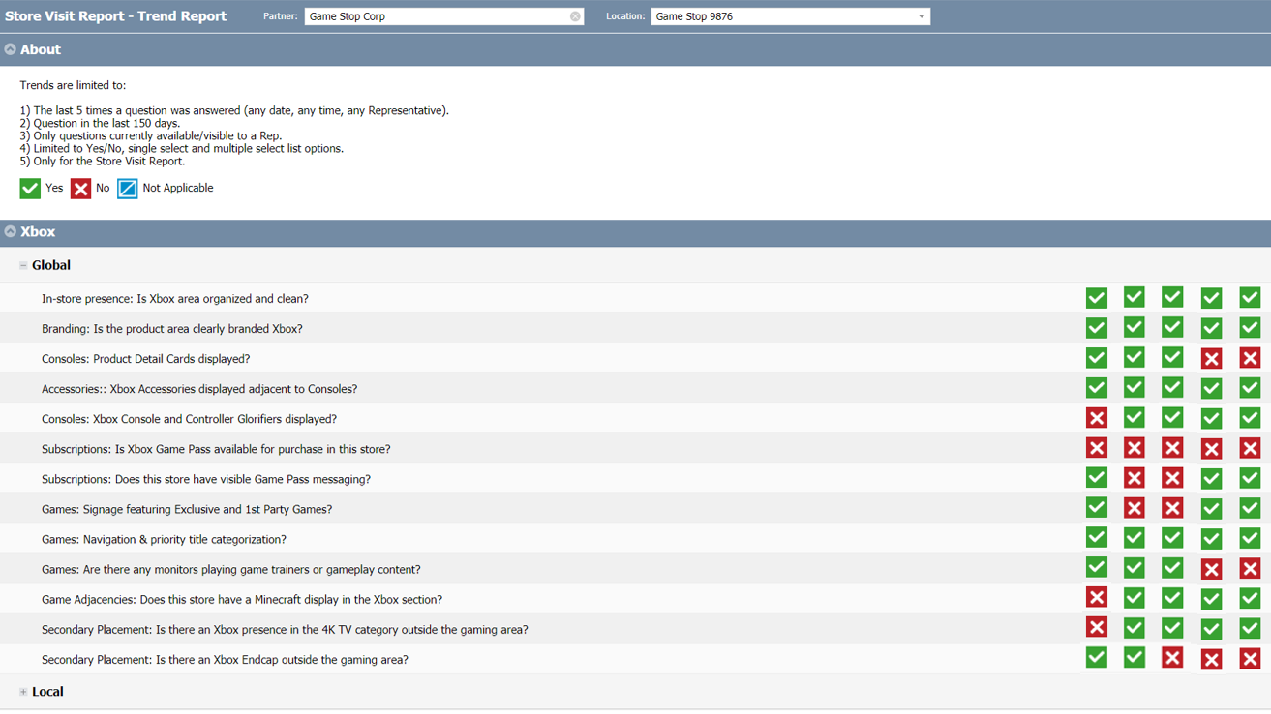
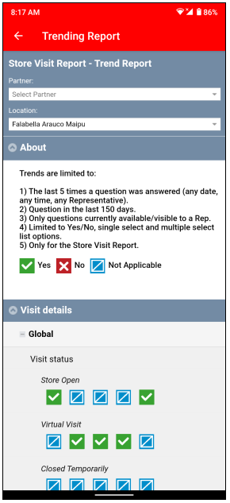 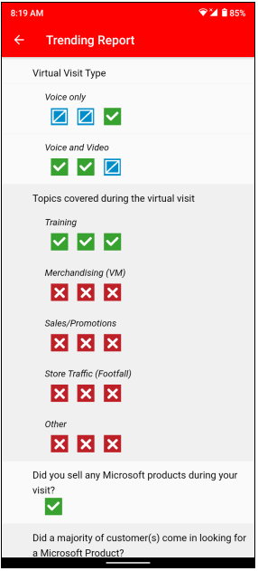 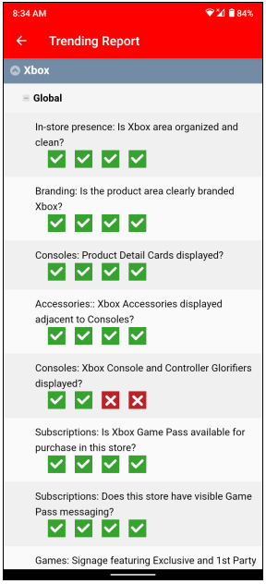 Android view
How do I Access this?
The first item in the Store Visit Report in the app will now provide a link directly to the trend for that store. The trend on that link has been optimized for mobile as well as a PC and will display slightly different views of the same information. Online access for Admins is found under the Reporting Center menu of www.msftreps.com.
What Does This Not Do?
- Not available for forms outside of Store Visit Report
- Will not show questions that have been suspended to stopped globally, regionally, and locally.
- Will not show questions that have aged beyond 150 days
- Save or store the report – Internet connectivity is required to use this “live” report.
How Can you Benefit More from this?
As you are adding questions locally or regionally, give some consideration to the Store Visit Report and formatting questions to be either Yes/No, Single Select or Multiple Select. Those questions will dynamically add themselves to the report and start providing you additional insight into each store now trending.

Legend and Chart Controls
To use the report, select a Partner and then a Location from the dropdowns, or simply pick a Location. The “About” blade will display the business rules and a response legend.
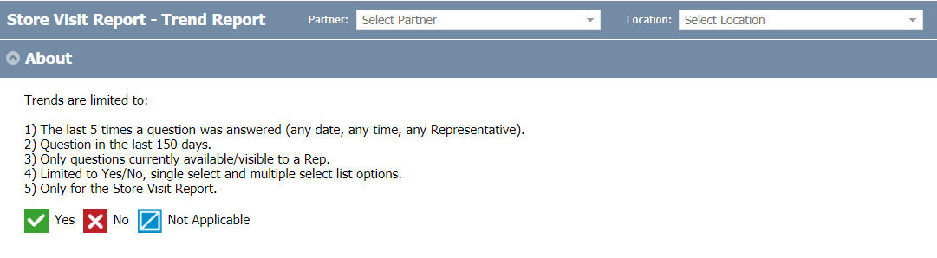
Yes / No question responses are indicated with a green check for a “yes” or red X for a “no.” Multi-select questions will also use the same green / red format for list items selected or not selected. Single-select questions will use the green check for indicating which list item was chosen and the blue square for remaining items.
The “About” blade has language localization added so Reps can see a translated version of the business rules and legend.
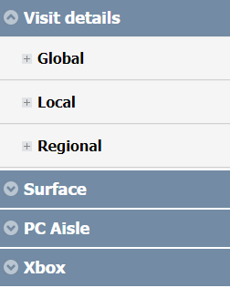
After a Location is selected, blades will appear with expand / collapse controls for sections of the Store Visit Report and then segregated sections for Global, Regional and Local sections. Response columns will show to the right of the questions.
On Windows if you hover your mouse (or tap on Surface, Android, and iOS) over the response boxes, the report will indicate with a hover tip how long ago each question was answered.
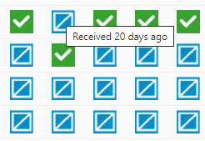

Note: Response columns may not always line up by submission date throughout the page. Each column is not a specific submission date. Remember that all the questions are trended individually and not all questions are answered with the same frequency. Some are only triggered conditionally as shown in the following example and the responses are put in a different column than the previous trigger question.
Example: When a Virtual Visit is chosen for Visit Status, here is how the triggered Virtual Visit Type response would be represented after occurring once in the last 150 days.
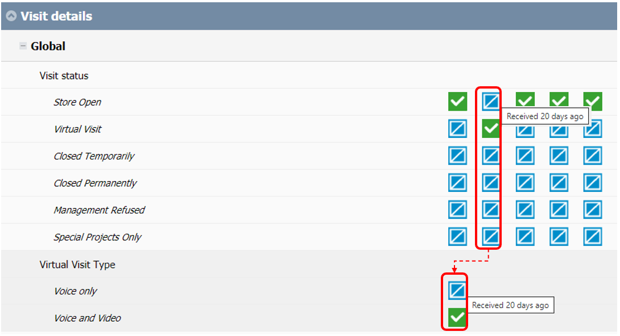

Support
Send any questions or concerns to msftreps@westlakesoftware.com. Please include the following.
- Your name
- MSFTREPS user email or 10-digit ID
- Country
- Device information (Make + Model + OS Version)
- Location name and date of the visit
- Description of the issue with any screenshots or error messages
- Diagnostics (found in Settings) copied to a text file and attached to email
Note: The more information you can give us with steps to reproduce what you are seeing, the better we can review and analyze.

Published March 26, 2021.

