RETAIL ENGAGEMENT PROGRAM

WINDOWS 8.1
CLIENT APPLICATION
USER GUIDE

Version 1.0

<06-Sep-2014>
Table of Contents
1. Introduction 3
2. Installation 4
3. Log In 5
4. Home Screen 6
5. Resource Files 11
6. Breaking News 13
7. Call Reports 14
8. Event Report 20
9. Word On The Street Report (WOTS) 21
10. RSP Training Form 22
11. Adding an RSP (Store Employee) 25
12. Store Notes 26
13. Outbox 28
14. Diagnostics 30
15. Preferences 31
16. Privacy Statement 35
17. About REP App 36
18. Permissions 37
19. Rate and Review 38
20. Quick Tips 39

1. Introduction

The Retail Engagement Program (REP) Windows 8.1 modern application, also known as REP client application can be installed and used on any devices running Windows 8.1 operating systems (tablets, laptops or desktop computers etc.). This application is designed for representative users for accessing training resources and submitting various reports.

REP Windows 8.1 Client Application allows representative users to:
- Access training resources to learn about new Microsoft products and services
- Submit ‘Store Visit Call Reports’ for recording store visit related information or in-store activities
- Submit ‘Event Reports’ to record details of 1:Many training events
- Add RSPs (store employees) in to the system
- Submit one-to-one RSP Training forms
- Submit ‘Word on the Street’ (WOTS) Reports for capturing competitive information and feedback
- Add Store Note

Notes:
- Users need a unique 10-digit identification number to log in to the application, usually assigned by country REP Administrators.
- This application requires a working Internet connection to be able to synchronize data with REP Server application (web application – www.msftreps.com). Synchronization involves downloading files, refreshing call reports, uploading report data to server etc.
- Users can also use the use this application in offline mode and save or submit data. When the user submits a report while Internet connection is off, it stays in the Outbox until connection resumes.
- This application is different from REP Windows Phone application, which is meant to be for users with mobile phones running Windows 8.1+ OS.

2. Installation

Please follow the below instructions for installing and setting up the REP client application on a Windows 8.1+ device (Surface RT, Surface Pro, PCs / Laptops with Windows 8.1 (or upwards) OS etc.)

- Open Windows Store app



- Search for Retail Engagement Program app. Alternatively, users can directly go to the link: http://ow.ly/xCveU (case sensitive)

- Select the application from the list (it will be the only one listed)

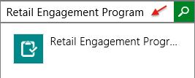
Note:
REP client application is optimized for Windows 8.1 version or upwards. It will not appear in the Windows store search results for earlier versions. Stepwise instructions on upgrading windows can be found at this page: http://windows.microsoft.com/en-au/windows-8/update-from-windows-8-tutorial

- Select to install

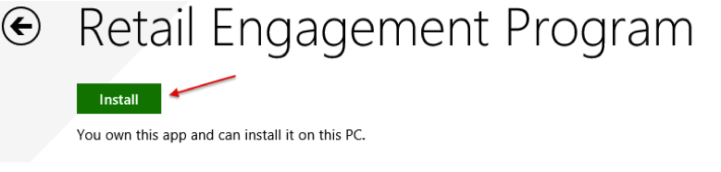
- The installation will happen automatically and Windows will notify when the installation is complete. After the installation, the application icon will appear on the Start screen or amongst other application icons. Look for this icon:
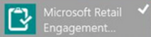

3. Log In

While running the application for the first time, the user will be asked to enter in his/her assigned 10-digit ID number. Users will be able to find this ID number on the ‘Welcome’ page of www.msftreps.com after logging in. Respective Country Administrators of Retail Engagement Program has to be contacted for assistance. After entering a valid user id please press OK to log in.

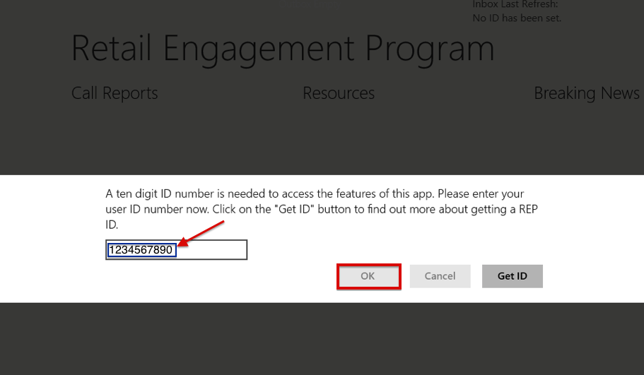

4. Home Screen

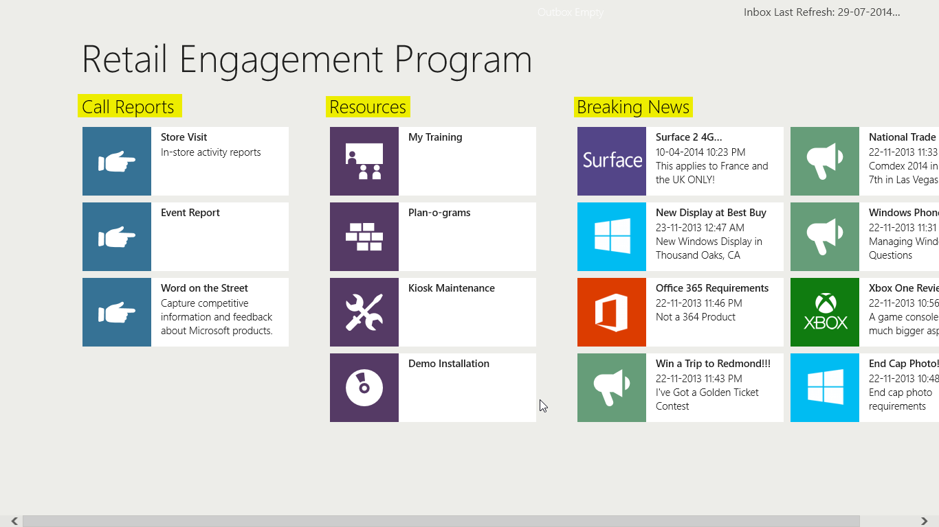

The home screen has three sections: ‘Call Reports’, ‘Resources’ and ‘Breaking News’

- ‘Call Reports’ section contains the following menu items (tiles):
  - ‘Store Visit’ – to record / submit various in-store activity call reports
  - ‘Event Report’ – to record / submit 1:Many training events
  - ‘Word on The Street’ – to record / submit competitor product information and feedback

- ‘Resources’ section contains the following menu items (tiles):
  - ‘My Training’ - Monthly training assignments and resource files
  - ‘Plan-o-grams’ - Store display information
  - ‘Kiosk Maintenance’ - Interactive display maintenance instructions
  - ‘Demo Installation’ – Demonstration instructions

- Breaking News
  - New Product Information and announcements in general or news pertaining to different retail products of Microsoft such as ‘Windows’, ’XBox’, ‘Office’, ‘Surface’, ‘PC Accessories’ and ‘Windows Phone’.
4.1 Inbox

‘Inbox’ at the top right corner of the home screen shows the status of various synchronization activities between the REP client application (app) and the server. While the device is connected to the Internet, the app periodically checks for new files / changes. A short description of the activity is shown in this Inbox field. Otherwise, it shows the last refresh date and time. Hitting the ‘Check Now’ button under ‘Preferences’ page in ‘Settings’ will force synchronization, in case auto refreshing does not happen.
See topic “15. Preferences” for more details on this.

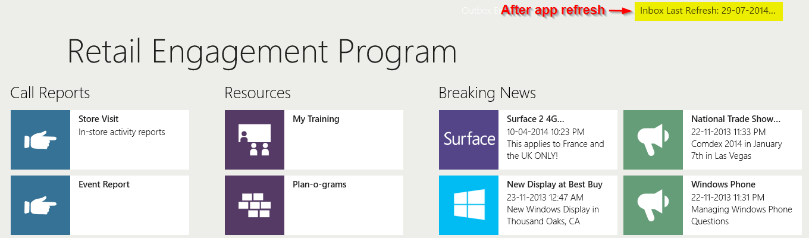

4.2 Closing the app or switch to another app

Users can close the app by dragging down from the top of the screen all the way to the bottom with either a finger (on a touch screen) or the mouse cursor. To switch to another app, press on the Windows / Start button or simply open another app.

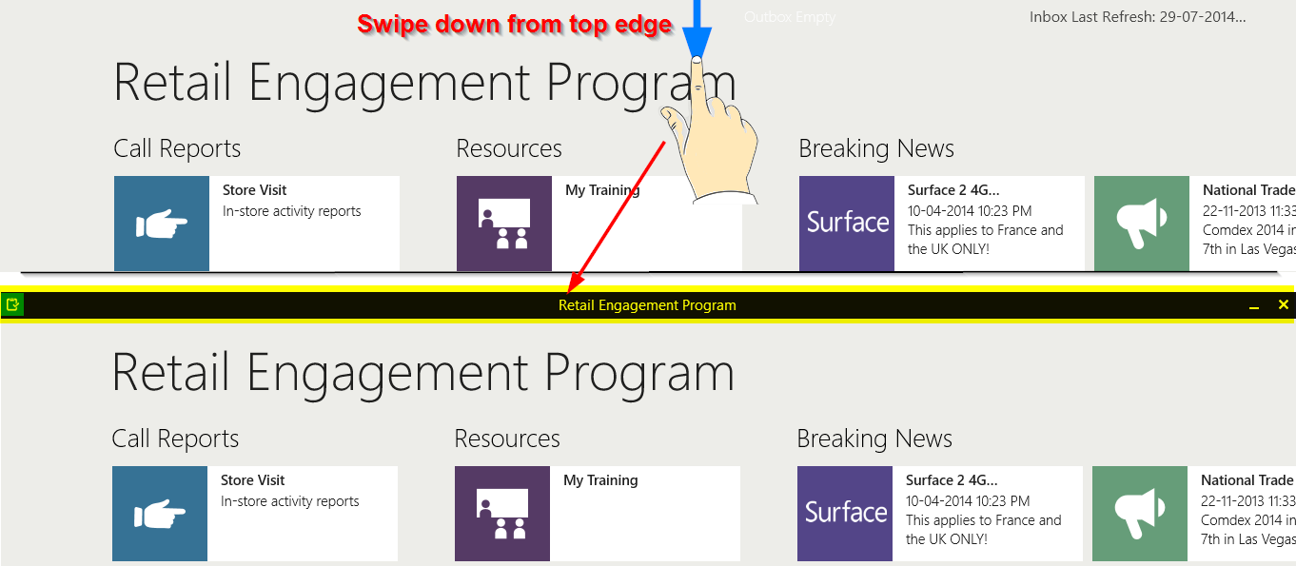

Note:
Closing the app or switching to another app will not fully stop / terminate the app. By doing so, it just goes into inactive / background mode (a dormant state). That means, the state of the REP app is saved and the user can almost always return to the app where he/she left it. This can be desirable if the user is multi-tasking (working on multiple apps including REP app). But, there are times when the user may want to completely terminate the REP app instance and open / start it afresh. A most common scenario is when the user wants to refresh the app content or invoke the start-up health check / recovery routine. In these cases, a different set of steps has to be followed, which is explained in the “20. Quick Tips” topic of this document.

4.3 Charms Bar

The Windows 8.1 Charms bar has options such as ‘Settings’, ‘Devices’, ‘Start’, ‘Share’, and ‘Search charms’ in it. The Charms bar is context sensitive to the application that is active. If the user brings up the Charms bar and clicks on ‘Settings’, he/she will see various options of REP application such as ‘Outbox’, ‘Preferences’, ‘Diagnostics’, ‘Privacy Statement’, ‘About’, ‘Permissions’ and ‘Rate and Review’.

Users can summon the charms bar using a mouse, keyboard or touchscreen by following these steps.
- Mouse: Point at the top- or bottom-right corners.
- Keyboard: Press the Windows key + C.
- Touchscreen: Slide your finger inward from the screen’s right edge.

Using mouse: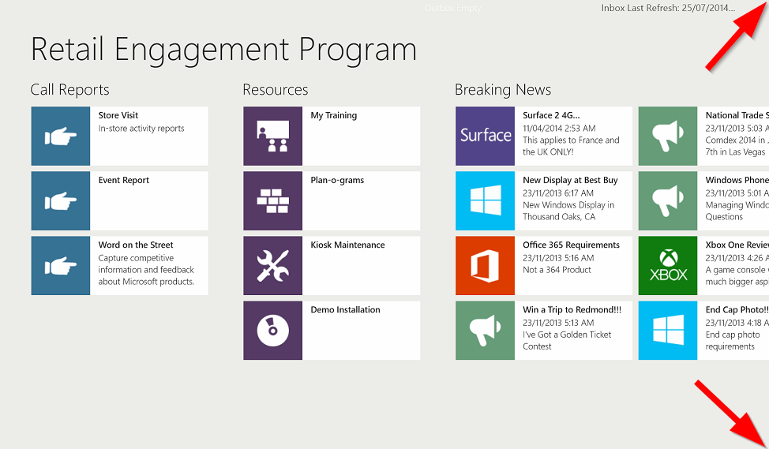
Using Touchscreen: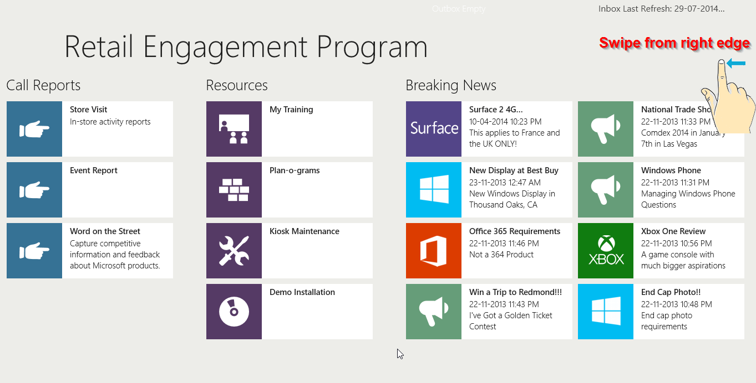
Charms bar:
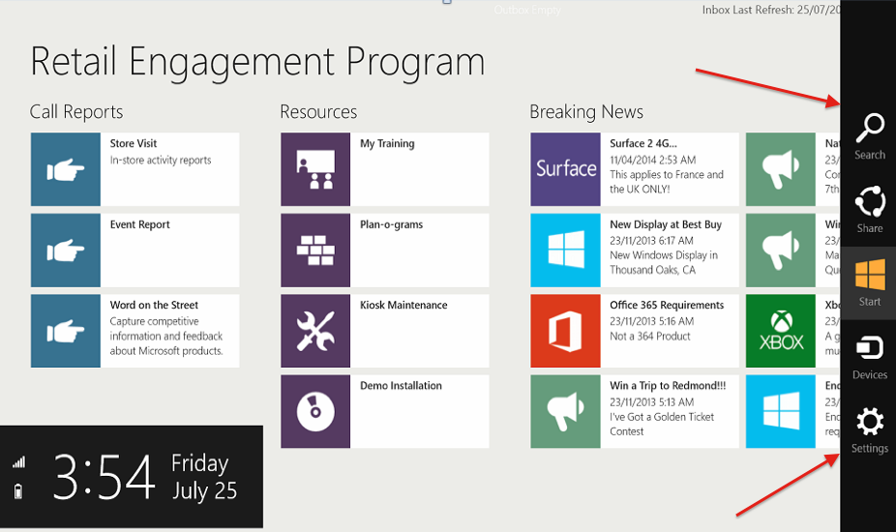

Tap or click ‘Settings’ icon to try out different options in REP app.
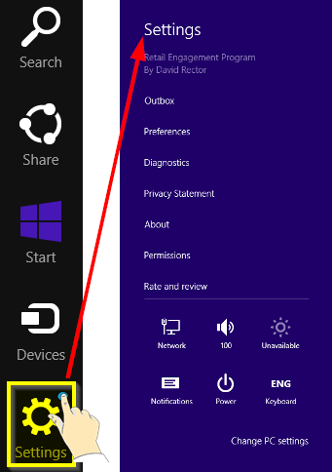

5. Resource Files

Resource files are training documents or personal development materials. Files in general. In REP system, Resource Files are classified in to four types – ‘Training’, ‘Plan-o-grams’, ‘Kiosk Maintenance’ and ‘Demo Installation’. Clicking on one of the tiles will take the user to the page where he/she can find resources files of the respective classification.

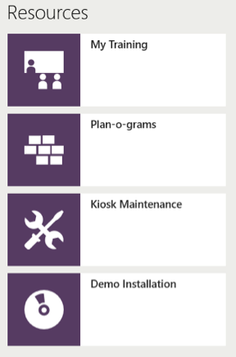

The picture below shows ‘My Training’ page. Training resources may have different sub categories in different countries. Files that are subcategorized will be displayed under respective headers. Other files are displayed under the header ‘Resources’.

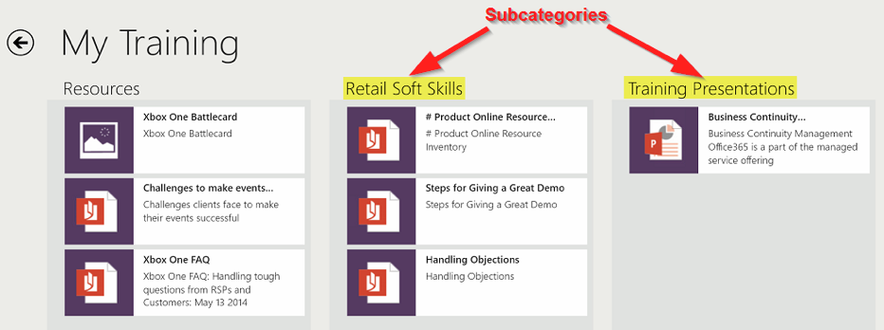

Users can open and read files of any of the popular type/format by tapping or clicking on the tiles. File will be automatically opened in its respective default player/app installed on the device. For example, a .PDF file will be opened in the default PDF reader installed in the device.

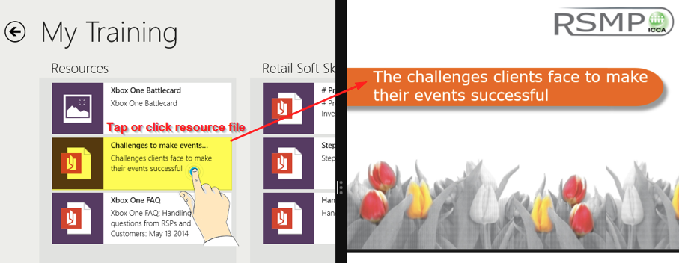

6. Breaking News

Breaking news items could be of one of the following 8 types, each denoted by a unique icon:

General | 
Windows | 
Surface | 
Office | 
Xbox | 
PC Accessories | 
Warning | 
Alert | 

Users will be able to see only those 'Breaking News' items created or published by their Country Administrator. Tap or click on news tile to read the news.

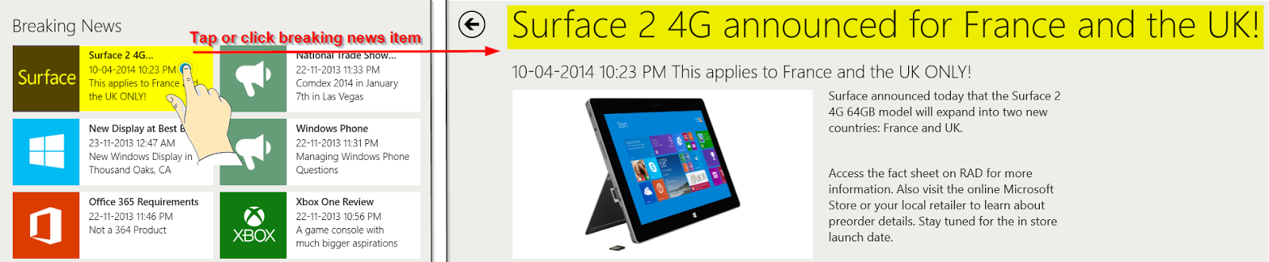

7. Call Reports

7.1 Store Visit


Tapping or clicking on ‘Store Visit’ tile will show the stores assigned to the user. Upon selecting a store from the list (on left side panel), the user will be able to see the list of available call reports for that store (on the right side panel).

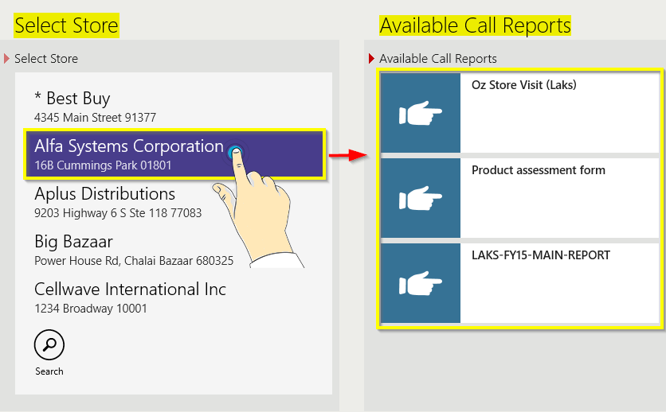

If there are many stores assigned to the user, he/she can scroll down on the left panel (stores list). Alternatively, the user can click the search button and type the store name. Clicking on search icon again will remove the search editor. See the picture below:

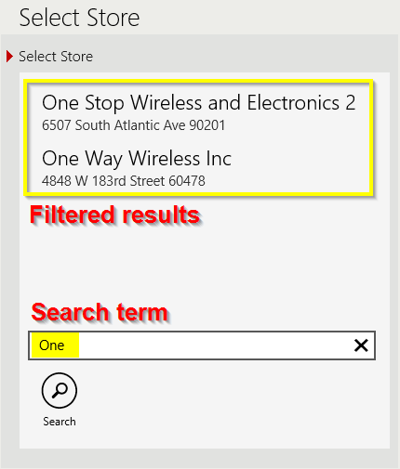

If the user has some store visits scheduled for that day, initially that list of stores will be shown by default. The user will be able to view the complete list of assigned stores by clicking on the “All Assigned Stores” button at the bottom. Please refer to the picture below for more clarity.

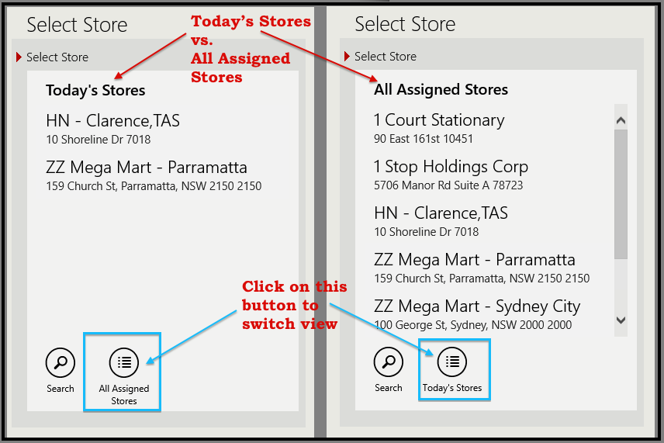

Selecting (touching / clicking) a call report on the right panel will open that report. There may be multiple call reports based on the activities for that store. So, the user has to contact his/her manager or country administrator to make sure the appropriate call report is used for a particular store. An example of an opened call report form is shown below:

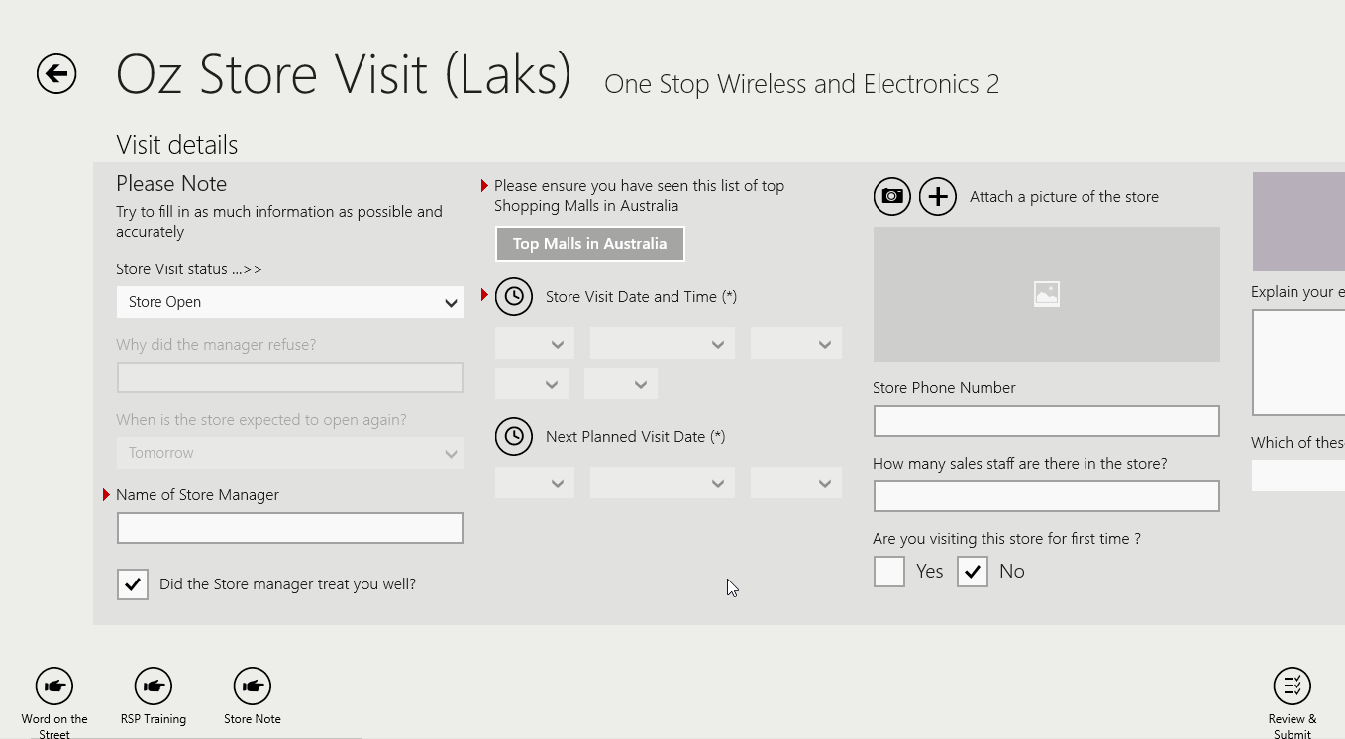

It must be noted that there can be multiple questions/fields in the call reports. Questions / fields in call report forms are grouped into various sections such as ‘Visit Details’, ‘Windows’, ‘Surface’, ‘Office’, ‘Xbox’, ‘PC Accessories’, ‘Windows Phone’ etc. Panning / scrolling right or left will let you see/access all sections and fields. Some fields may be hidden or greyed out. These have conditional logic attached to it and become visible / accessible only when one of the related preceding question is answered.

7.2 Jumping across sections
Instead of scrolling, the user can directly jump from one section to another using the navigation bar at the top. It can be opened by swiping down from the top frame of the app or right clicking anywhere on the call report screen. This feature is useful when handling long forms with many sections and fields.

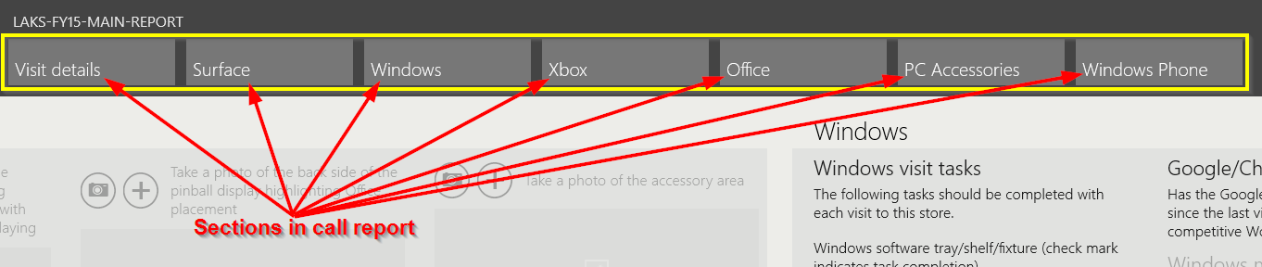

7.3 Required Fields

Call reports may have ‘required’ fields – that must be answered before submitting. Such ‘required’ fields are marked with a red triangle. An example is shown in the image below.

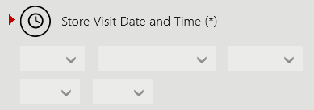

While submitting a call report, if a required field is missed (left unanswered), an alert message is shown (see below).



7.4 Call Report Submission

When a store visit call report is completely answered, users can click on the ‘Review & Submit’ button at the bottom right of the screen (shown below).

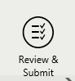

Clicking on this button takes the user first to a ‘Review’ page where the answers can be reviewed before submitting. Subsequently, pressing the ‘Submit’ button at the lower right corner of the review page (shown below) will post the call report to the Outbox. If Internet connection is active, the Outbox will begin transmitting the form to the server. It must be noted that once a form is submitted to the Outbox, it cannot be edited. If Internet connection is not there, the Outbox will hold the item until connection resumes.

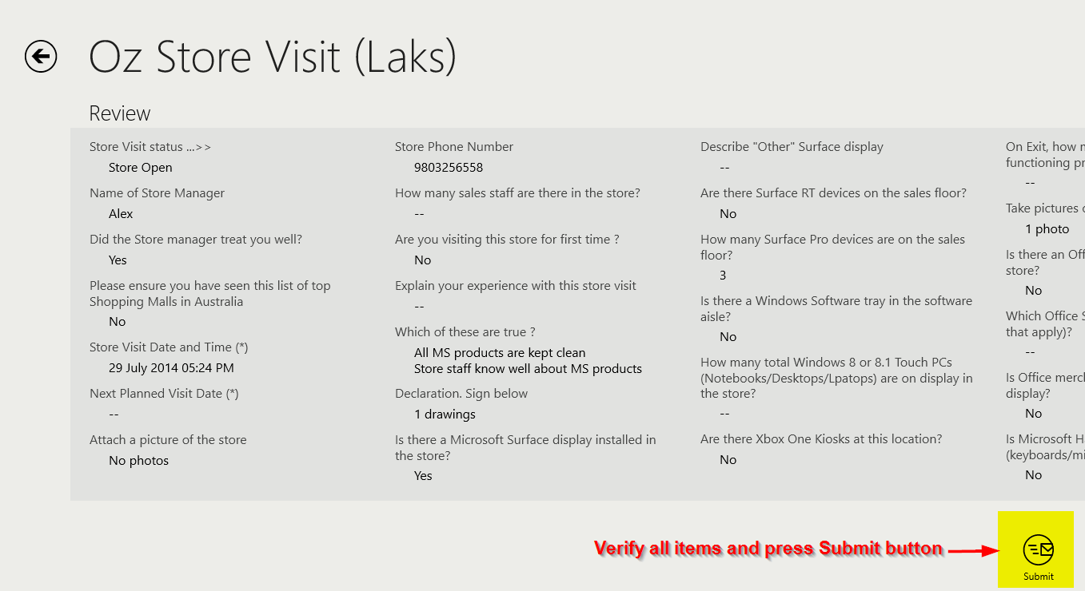

7.5 Saving and retrieving a call report

While the user is in the middle of answering a call report, he/she may face the need to access some other modules of the application or simply return to the previous page to access another call report. The user will be clicking on the back button  to go back. In such cases, the application will prompt the user to ‘Save’ the report. If chosen to save the report, the next time the user returns to the same form (of the same store), he/she will be able to restore the values saved in the previous usage/session. This saves a lot of time.

The prompt to restore previously saved values looks like below:
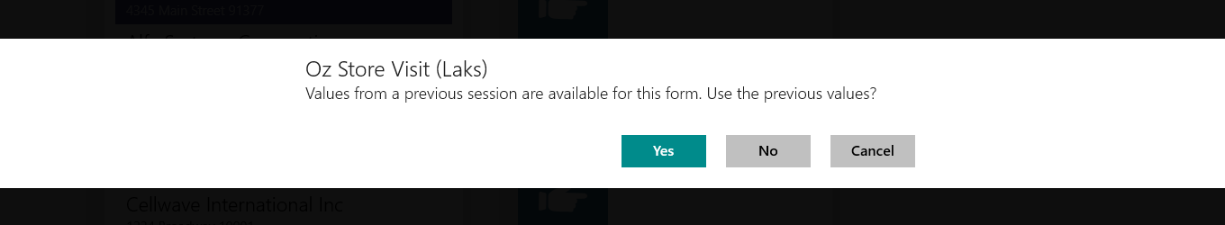
- Choosing ‘Yes’ - will restore the form with old values
- Choosing ‘No’ - will reset all saved values and present an empty form
- Choosing ‘Cancel’ - will let the user stay in the home screen (i.e. not open the call report)

7.6 Shortcut links for WOTS, RSP Training and Store Note:

At the bottom left corner of ‘Store Visit’ page and call report pages, there are shortcut links to open WOTS report, RSP Training Report and Store Note. See the picture below.

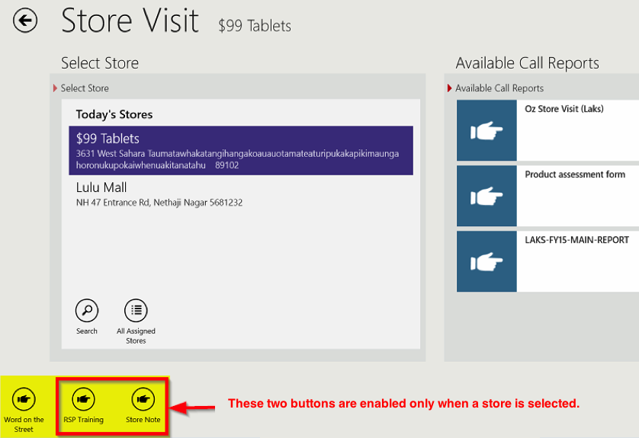

8. Event Report



Event reports capture the information from “one-to-many” training sessions. Below is an example of the layout. In comparison, RSP Training reports are for “one-on-one” sessions.

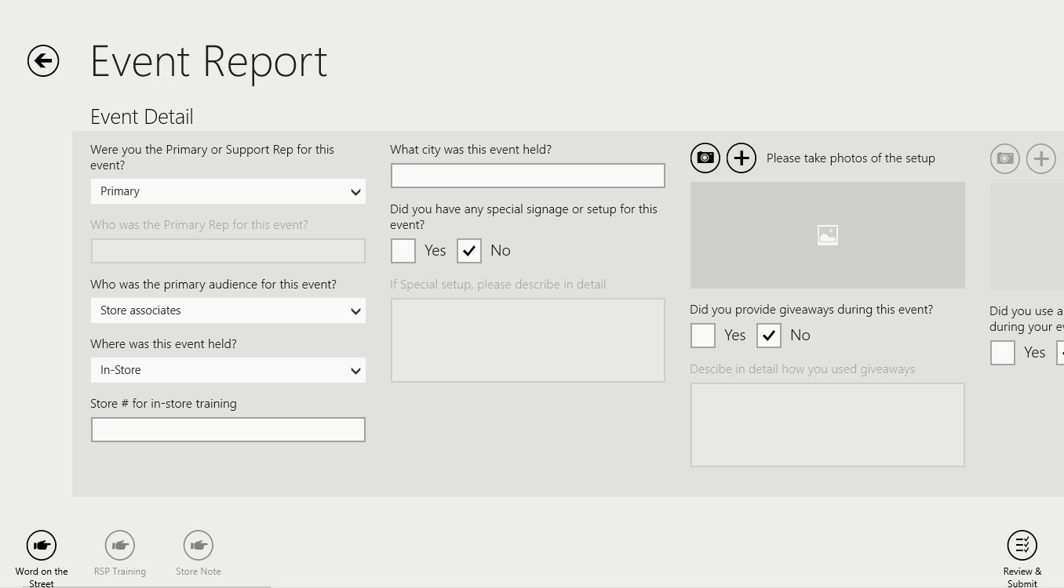

The process for completing and submitting an Event call report is the same as a store visit. See the Store Visit section earlier in this guide for reference.

9. Word On The Street Report (WOTS)

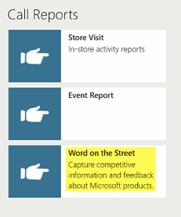

Word on the Street (WOTS) report is used to capture competitive information, customer feedback and RSP feedback. The process for completing and submitting a WOTS report is the same as for a Store Visit call report. See the Store Visit section earlier in this guide for reference.

During a store visit, there may be multiple instances where a WOTS report would need to be completed. WOTS reports can be accessed while working inside other call reports. A quick launch button is available at the lower left hand corner of the screen. Similarly, users can access WOTS reports from Event Report screen also. See “Shortcut link for WOTS” for more information.

Look for this button at the bottom left corner:


10. RSP Training Form

Training store employees (RSPs) is an essential part of a store visit. RSP Training form can be accessed from inside of store visit call reports forms through the shortcut link at bottom left corner.
The button looks like this:
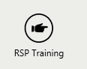

The RSP Training icon will be disabled until a store is selected. Select a store, and then click on the RSP Training button. When the form opens, select a store employee from the list on the left (or add a new one), then select ‘Next’.

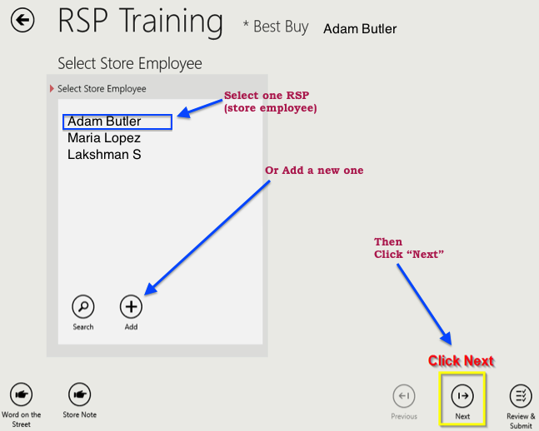
Example of RSP Training Form:

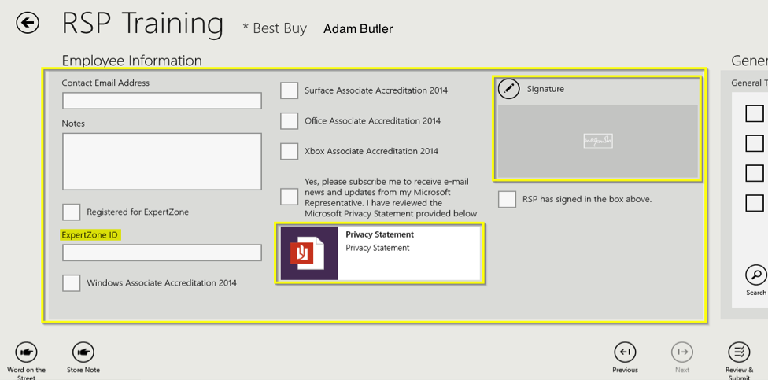

The ‘Employee Information’ section on the left captures details of the store employee. If ExpertZone information is available in the country, then enter it in the ExpertZone ID field. Currently, only manually entered information for ExpertZone accreditations are available. New RSPs will be shown the Privacy Statement and Signature field.
Scrolling to the right, there are monthly training items for each category (Windows, Office, Surface, Xbox and PC Accessories). User can quickly jump to different sections by using top navigation bar. Reference Top navigation bar.

On the right side of each group of training topics, users can find related resource files.

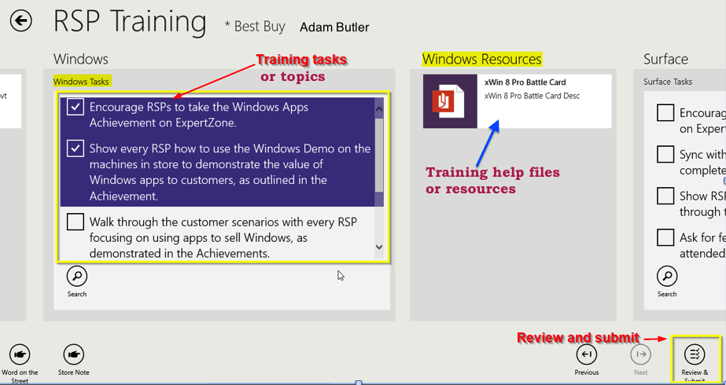

Select the training topics that were covered during the session. Review and Submit. The history of training for the RSP is maintained in the application database. On the next visit, they can be trained on any of the remaining topics. It is expected that the user will submit one RSP Training form for every one-on-one training session completed. In one session, multiple training topics can be covered.

11. Adding an RSP (Store Employee)

If there are no employees listed on the left, the user will have to add a new store employee in to the system, before an RSP form can be submitted for that store employee. For that, the user can click on the ‘Add’ (plus sign) button. A popup dialog will be opened (as shown below). User can enter the first and last name of the store employee and click ‘Add’ (tick sign) button again to complete addition. Users can add as many store employees as they want. But, the app will not allow the user to duplicate employee names (first name + last name combination).

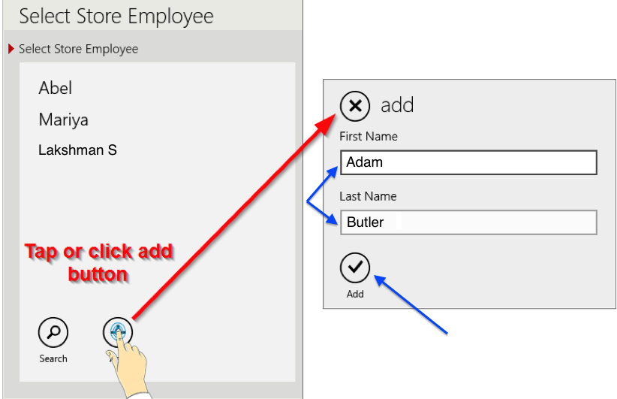

12. Store Notes

Store notes are reminders or helpful hints about a store. During a store visit, there may be instances where store notes need to be added. Store notes can be submitted while working inside call reports, before or after. A launch button (as shown below) will be seen in the lower left hand corner of the screen. Users have to select a store before they can submit a store note.

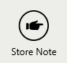

Users can launch Store Notes page from Store Visit page, Call Reports and RSP Training form. Look for the above icon at the left bottom corner.

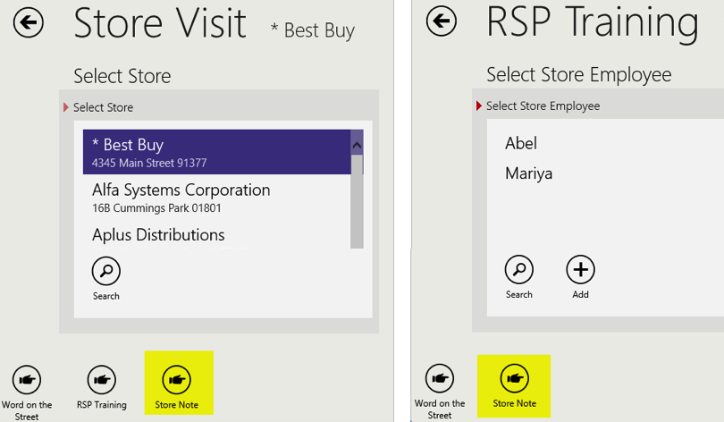

Once Store Note page is open, type in the notes, review and submit. Users will also be able to see all notes entered by other reps about that particular store.

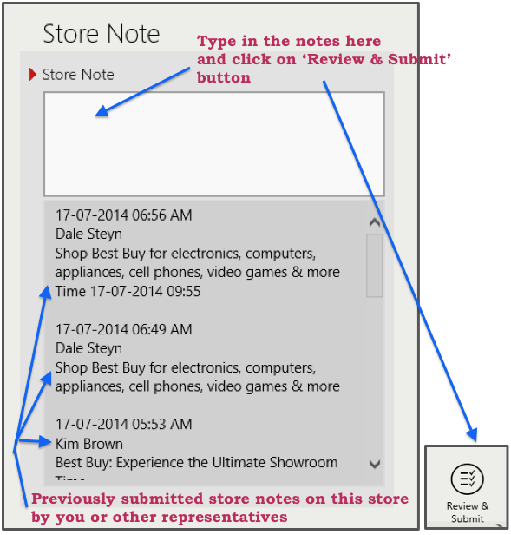

13. Outbox

The Outbox of REP app can viewed through ‘Charms Bar’ >> ‘Settings’. REP outbox can be compared to the outbox of an email application. This is an intermediate place where all submitted forms / records are stored before they are processed further and uploaded to the server.

Submitting a report in REP app is carried out in two stages. First, every submitted form/record with its attachments is sent to the Outbox. Then the record is uploaded to the server. This 2 stage submission allows REP app to work even in offline mode. When Internet connection is available, the Outbox will automatically start uploading (transmitting) records to the server (to www.msftreps.com). This happens as a background activity and users can do other things with the app in parallel. While the uploading happens, the Outbox will show a status / progress indicator at the top right corner of the home page as well as on the Outbox page. If the device is not connected to the Internet or if Internet connection is very weak, submitted records will be stored in the Outbox until Internet connection resumes. Depending on the number of photos attached to a form, uploading can take between several seconds to minutes (also depending on Internet speed). Call reports or Store notes submitted and successfully transmitted (uploaded) to the server can be viewed through the Web Application (Server Application) www.msftreps.com.

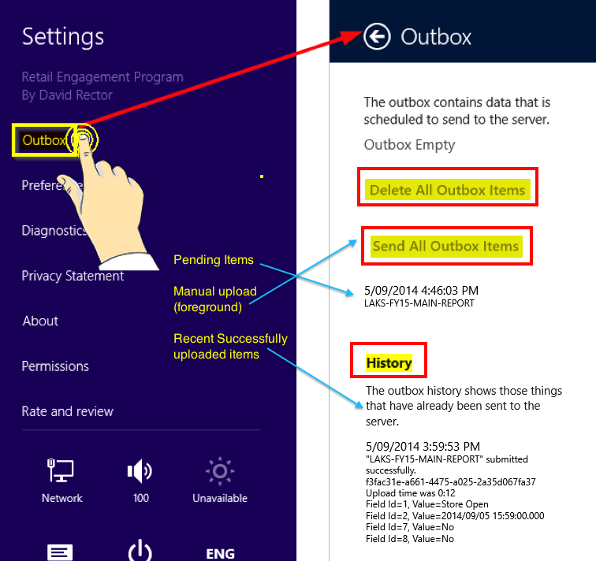

“Delete All Outbox Items” button:
Once a form or record is submitted to Outbox, users cannot modify them. However, they can delete all pending items in Outbox before they are uploaded to the server. To do that, users have to click on the “Delete All Outbox Items” button in the Outbox pane (see the picture above). This button will be inactive if there are no items in the Outbox.

“Send All Outbox Items” button:
It is not a good practice to let items pile up in Outbox, as it can affect the performance of the app. At times, the automatic processing of Outbox items and uploading to server fails due to various reasons. Users will see the number of pending items in Outbox increasing. In such cases, “Send All Outbox Items” button must be clicked to manually force uploads instead of waiting for the background uploading to automatically reattempt. This way of manually forcing upload is also called as foreground upload. It is important to note that while foreground uploading is in progress, users should not let the device go to sleep-mode or switch to another app, change the screen etc. as that can interrupt the upload and permanently damage the records, rendering them corrupt and irrecoverable. After all pending items are successfully uploaded to the server, the app will pop up a success message.

Note:
Outbox feature of REP app depends on the operating system and resources of the devices to handle automatic / background uploading to the server. Hence, there is a possibility that the automatic transmission process is affected or interrupted by device settings, settings of other apps, resources consumed by other apps, records getting corrupted due to the residues of an older version of REP app etc. In such cases, the auto recovery function of Outbox may not work as expected and users will have to resort to foreground uploading by clicking “Send All Outbox Items” button. If foreground uploading also fails to clear up the items in the Outbox, it is possible that those items (records) are permanently damaged / corrupted and cannot be recovered. In such situations, uninstalling and reinstalling the app would be necessary to continue using the app. But, be aware that doing so will wipe off all outbox items. So, as a good practice, users should ensure that number of submitted items in the Outbox pending upload is never more than a few at any given time. This avoids the risk of losing large number of records in case the user has to re-install the app.

History:
The ‘History’ section in the Outbox page will show a short description of each recent successful submission to the Outbox that have been transmitted to the server. Those items yet to be uploaded (i.e. pending items) are shown in the space between ‘Send All Outbox Items’ button and ‘History’ section. Please refer to the picture above.

14. Diagnostics

The Diagnostic Report feature, viewed through ‘Charms Bar’ >> ‘Settings’, allows users to send technically relevant details of the device, operating system, user ID, last inbox / outbox activities, errors and exceptions (if any) etc. to the REP technical support team. This is a technical log file of the application and would help the technical support team troubleshoot / diagnose a problem faster.

Here are some typical scenarios when diagnostic records are highly desirable to be sent:
- Record(s) appear to be stuck in Outbox / not being transmitted to REP server
- User submitted a report, it has gone out of Outbox, but cannot find it in Transaction Reports on REP web application (www.msftreps.com)
- Call reports, Breaking News, etc. are not displaying properly on the client app.

To send a Diagnostic Report, go to 'Charms Bar' >> 'Settings' >> 'Diagnostics' and click on the 'Copy Diagnostic Report' button, which will copy the report to the clipboard. Then users can paste it on the trouble ticket description box. Trouble Ticket form can be found at this url: https://www.msftreps.com/docs/HelpDocs/REP-HelpDocs.html?TechnicalSupport.html

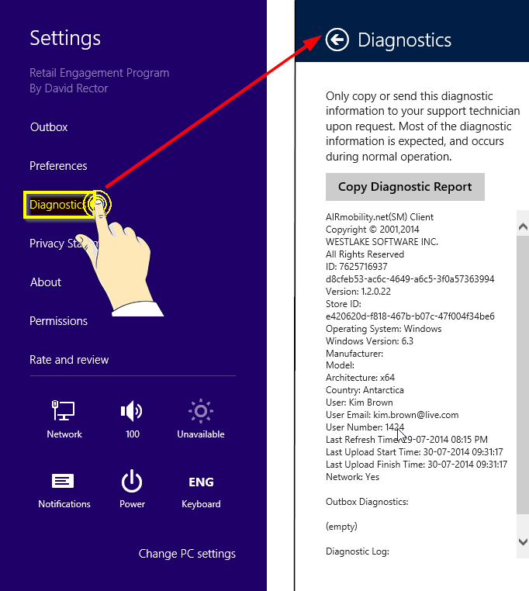

15. Preferences

Found in ‘Charms Bar’ >> ‘Settings’, the ‘Preferences’ pane provides options to verify or update the user ID (Change ID), refresh call reports forms, refresh resource files & breaking news (Check Now), show the Outbox and change REP language preference (Select Preferred Language).

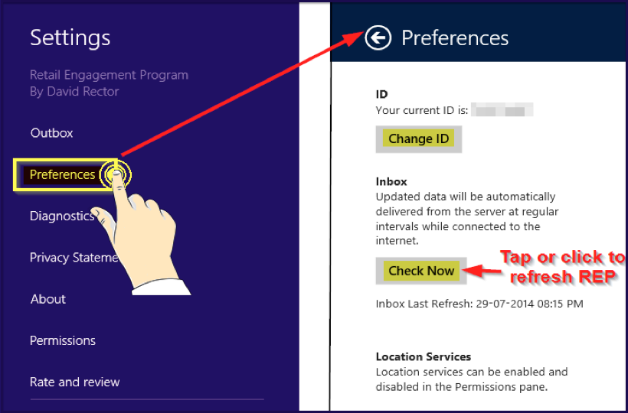

15.1 Preferred Language

Users can set a preferred language for REP App. By doing so, the user will be able to see Resource Files, Breaking News, call report fields etc. in the preferred language, provided corresponding translations are made and saved on the REP server. Contact Country Administrators for more information.

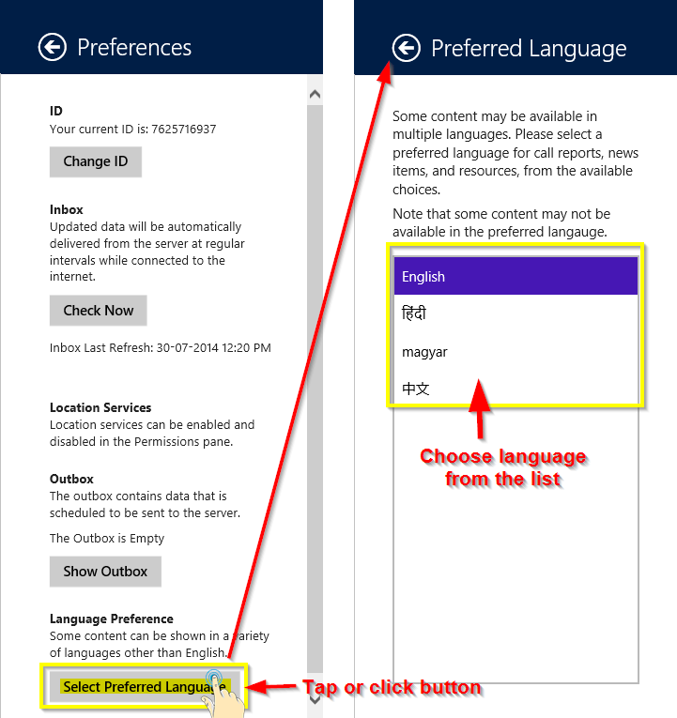

15.2 Change User ID

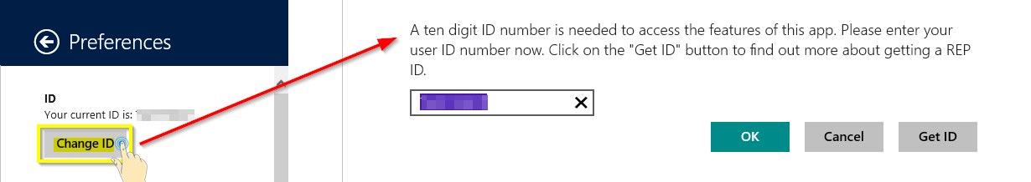

15.3 Show Outbox

Show Outbox button allows user to jump to the Outbox settings from preferences section.

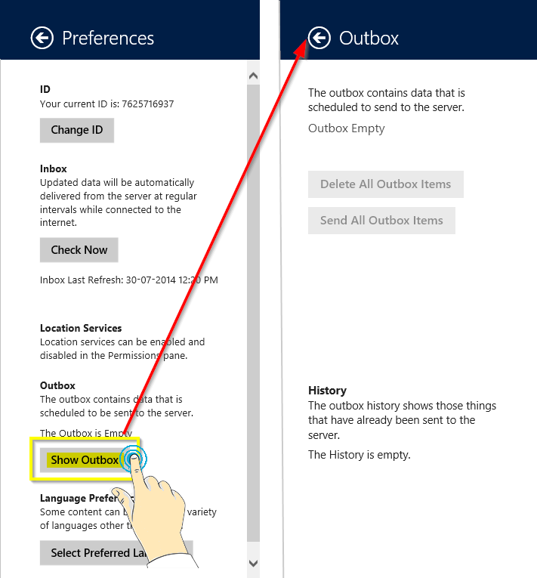

15.4 Image Preview

Enabling ‘Image Preview’ option under Preference pane will allow the user to view Image Resource Files added in call reports as thumbnails. Please refer to the pictures below:

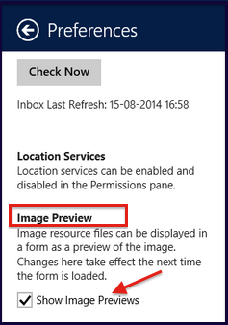

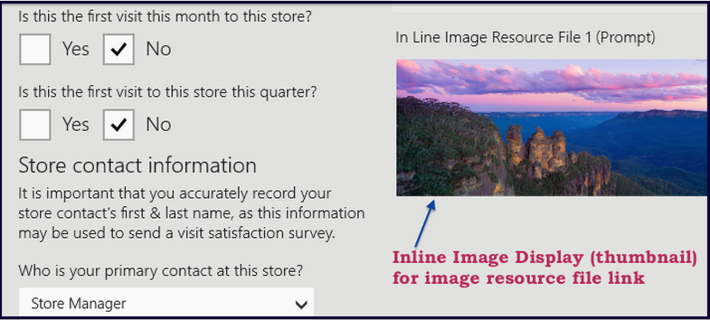

16. Privacy Statement

Privacy statements for using REP app can be viewed by clicking on Charms bar >> Settings >> ‘Privacy Statement’

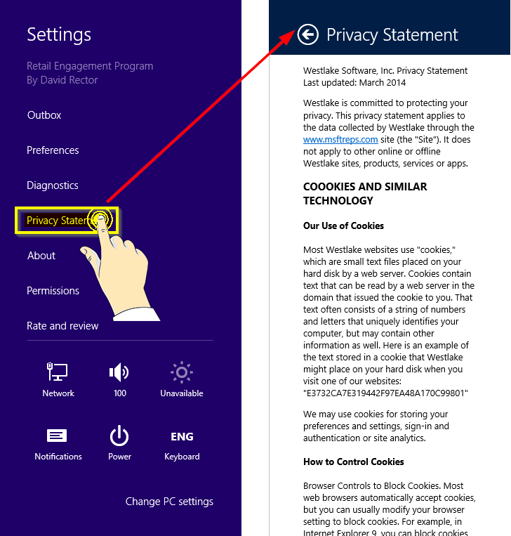

17. About REP App

Go to ‘Charms bar’ >> ‘Settings’ >> ‘About’ page to view details about the REP application, its version number etc.

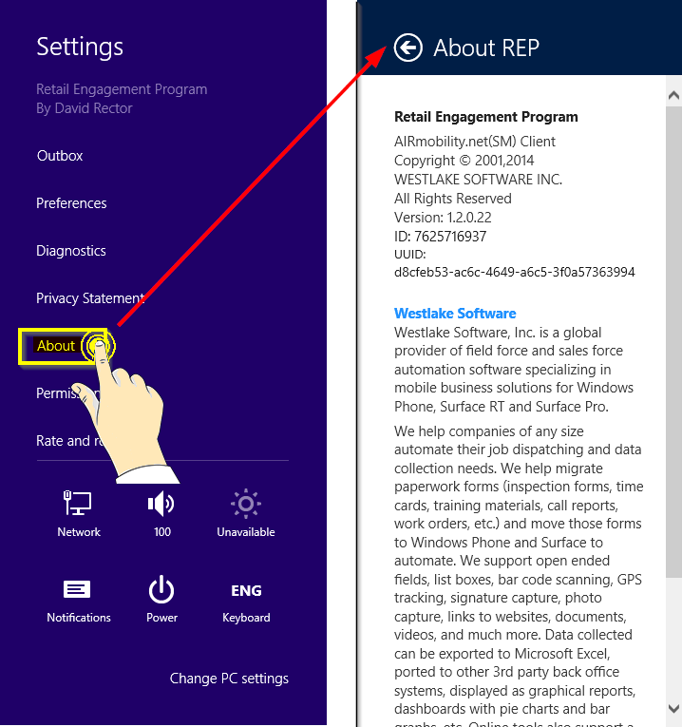

18. Permissions

Through ‘Charms bar’ >> ‘Settings’ >> ‘Permissions’ page, users can allow or deny REP app access to device location (GPS) and webcam.

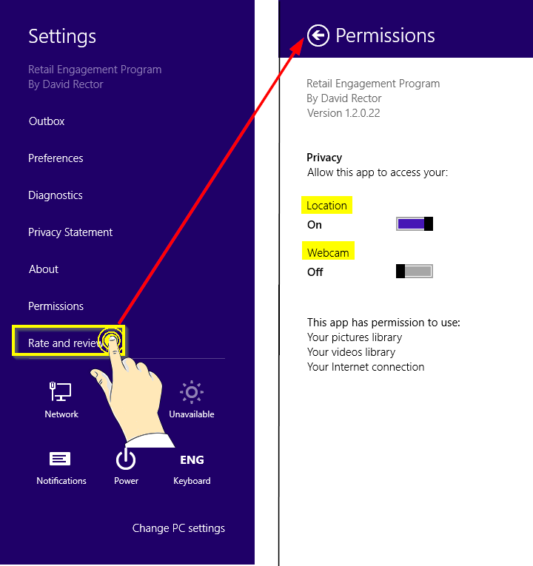

19. Rate and Review

In the ‘Charms bar’ >> ‘Settings’ >> ‘Rate and review’ page, users can enter feedback about this app.

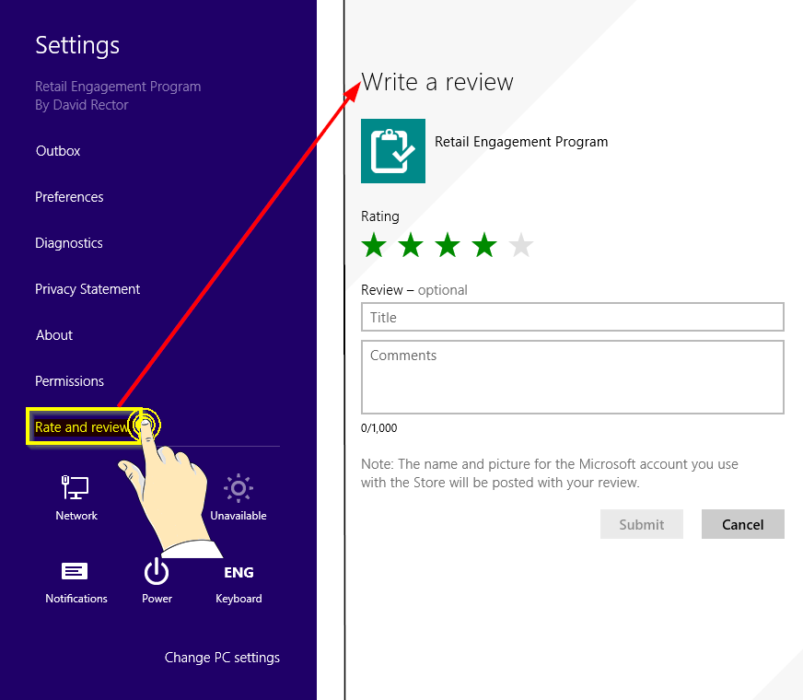

20. Quick Tips

Please go to this web page to find tips on following items:

https://www.msftreps.com/docs/HelpDocs/REP-HelpDocs.html?AppendixDQuickTips.html

- Sending Diagnostic Report
- Changing settings for sleep function on Windows 8.1+ device
- Upgrading the client application to a newer version
- Clean re-installation of client application
- Refreshing data on client application
- Check the version of client application
- Completely stopping the client application
- Changing the user on client application
- Viewing Outbox History on client application

If you have records stuck in Outbox, please refer to this page for help topics:

https://www.msftreps.com/docs/HelpDocs/REP-HelpDocs.html?OutboxHelp.html

